

FACULTY OF COMPUTING AND INFORMATICS
DEPARTMENT OF COMPUTER SCIENCE
MASTER’S THESIS
Title:

DESIGNING A SECURE MOBILE APPLICATION FOR SMART PREPAID ENERGY METERS IN NAMIBIA
by
Barminas Steve Zeraua
200100408

Thesis submitted in fulfilment of the requirements for the degree of Master of Computer Science at the Namibia University of Science and Technology
Supervisor:
Prof. Attlee M Gamundani
Co-supervisor:
Ms. Teresia Ankome

June 2026
METADATA
TITLE: Mr
STUDENT NAME: Barminas Steve Zeraua
SUPERVISOR: Prof. Attlee M Gamundani
CO-SUPERVISOR: Ms Teresia Ankome
DEPARTMENT: Faculty of Computing and Informatics
QUALIFICATION: Master of Computer Science
SPECIALISATION: Mobile Application
STUDY TITLE: Designing a Secure Mobile Application for Smart Energy Meters in Namibia
KNOWLEDGE AREA: Secure Mobile Application Development
KEYWORDS: Smart Meters, Internet of Things, Mobile Application, Cybersecurity, Encryption
TYPE OF RESEARCH: Design-Based Research
METHODOLOGY: Qualitative Methodology
STATUS: Thesis
SITE: Namibia University of Science and Technology
DOCUMENT DATE: June 2026
SPONSOR: NamPower

Declaration

I, Barminas Steve Zeraua, hereby declare that the work contained in the thesis entitled: Designing a Secure Mobile Application for Smart Energy Meters in Namibia is my own original work and that I have not previously in its entirety or in part submitted it at any university or higher education institution for the award of a degree.

Signature: ………………………………………………. Date: …………………………….

I, Prof. Attlee M Gamundani, hereby declare that the work contained in the thesis entitled: Designing a Secure Mobile Application for Smart Energy Meters in Namibia was under my supervision.

Signature: ………………………………………………. Date: …………………………….

Retention and Use of Thesis

I, Barminas Steve Zeraua, being a candidate for the degree of Master of Computer Science accept the requirements of the Namibia University of Science and Technology relating to the retention and use of theses deposited in the Library and Information Services.

In terms of these conditions, I agree that the original version of my thesis deposited in the Library and Information Services will be accessible for purposes of study and research, in accordance with the normal conditions established by the Librarian for the care, loan or reproduction of theses.

Signature: ………………………………………………. Date: …………………………….

Table of Contents

Table of Contents 5
List of Figures 8
List of Tables 9
List of Acronyms 10
Acknowledgements 11
Abstract 13
Chapter 1: Introduction 14
1.1 Overview 14
1.2 Introduction 14
1.3 Background 16
1.4 Problem Statement 17
1.5 Research Objectives 18
1.5.1 Research Objective (s) 18
1.5.2 Research Question (s) 18
1.5.3 Contribution of the Research 19
1.6 Delineations and Limitations 19
1.7 Assumptions 19
1.8 Ethical Considerations 20
1.9 Thesis outline 20
Chapter 2: Literature Review 23
2.1 Overview 23
2.2 Mobile Applications 23
2.3 Mobile Application Platforms 24
2.3.1 iOS Mobile Platform 25
2.3.2 Android Mobile Platform 25
2.4 Mobile Application Vulnerabilities 26
2.5 Mobile Applications Secure Features 28
2.6 Smart Energy Meters 34
2.7 IoT for Smart Energy Meters Vulnerabilities 37
2.8 Smart Meters Secure Features 39
2.9 Cybersecurity Framework 40
2.10 Research Gap 43
2.11 Summary 44
Chapter 3: Research Methodology 45
3.1 Overview 45
3.2 Research Paradigm 45
3.3 Research Design 47
3.4 Data Collection 48
3.5 Participants/Population 50
3.6 Data Analysis 50
3.7 Project Management 51
3.8 Summary 54
Chapter 4: Requirement Analysis 56
4.1 Overview 56
4.2 Functional Requirements 56
4.3 Non-Functional Requirements 57
4.4 Summary 58
Chapter 5: System Design and Architecture 59
5.1 Overview 59
5.2 Use Case Diagram 59
5.3 Activity Diagram 62
5.4 Conceptual Data Model 62
5.5 System Architecture 63
5.6 User Interface 64
5.7 Summary 65
Chapter 6: Implementation (Prototype) and Testing 66
6.1 Overview 66
6.2 Smart Energy Meter 66
6.3 Eclipse Mosquitto 67
6.4 VS Code MSSQL Database 69
6.4.1 Database Tables 70
6.4.1 Stored Procedures 72
6.5 Python 72
6.6 Visual Studio Code 73
6.7 Application Programming Interface (API) 74
6.7.1 Two-Factor Authentication API 75
6.7.2 Email Verification API 75
6.8 Testing 75
6.8.1 Functional/ Unit Testing 76
6.8.2 Security Testing 76
6.8.3 Performance Testing 77
6.9 Challenges 77
6.10 Summary 78
Chapter 7: Evaluation and Results 79
7.1 Overview 79
7.2 Functional/Unit Testing 79
7.3 Security Testing 79
8.3.1 Penetration Testing 80
8.3.2 Secure Code Review 80
7.4 Performance Testing 80
7.5 Interviews and Questionnaires 80
8.5.1 Interviews 81
7.6 Summary 86
Chapter 8: Conclusions and Future Work 88
References 89
Appendices 95
Appendix 1 Request to Conduct Academic Research at NamPower 95
Appendix 2 Authorization to Conduct Academic Research 96
Appendix 3 Python Snippet 97

List of Figures

Figure 1: Number of app downloads from 2016 – 2021 (Annual Mobile App Downloads Worldwide by Store 2026 | Statista, 2021). 23
Figure 2: OWASP Top 10 Mobile Vulnerabilities (Sachdeva, 2022) 26
Figure 3: How RSA Encryption Works (Nisha & Farik, 2017) 31
Figure 4: Typical Smart Meter Communication (Garcia, 2021a) 33
Figure 5: IoT Vulnerabilities from 37
Figure 6: Firewall and Smart Meters 38
Figure 7: NIST CSF from 39
Figure 8:The Iterative Process of Design-Based Research (Armstrong et al., 2020) 46
Figure 9: PXP Process Phases 51
Figure 10: Project Schedule 56
Figure 11: SUSE Linux Filesystem Structure 57
Figure 12: Landis+Gyr E65C Smart Meter 58
Figure 13: SAP HANA Lifecycle Management 60
Figure 14: Qualys Agent Deployment 61
Figure 15: Use Case Diagram – Secure Mobile Application for Smart Prepaid Meters 64
Figure 16: Activity Diagram - Secure Mobile Application for Smart Prepaid Meters 66
Figure 17: System Architecture - Use Case Diagram – Secure Mobile Application for Smart Prepaid Meters 67
Figure 18: Mobile Application Wireframes 68

List of Tables

Table 1: Android mobile platform versus iOS 24
Table 2: Android Security Guidelines 28
Table 3: Tools and Framework (Sachdeva, 2022) 32
Table 4: Smart Meter Communication Protocols (Garcia, 2021a) 34
Table 5: OBIS code 35
Table 6: Example of OBIS Code Translation 36
Table 7: Common Testing Frameworks 48
Table 8: Use cases Description 64

List of Acronyms
AES - Advanced Encryption Standard
ASDU - Application Service Data Unit
API - Application Programming Interface
APK - Android Application Package
DBR - Design-based Research
DES - Data Encryption Standard
DoS - Denial-of-Service
DDOS - Distributed Denial-of-Service
HANA - High-Performance Analytic Appliance
SNMP - Simple Network Management Protocol
IEC - International Electrotechnical Commission
iOS - iPhone Operating System
IDE - Integrated Development Environment
IoT - Internet of Things
MFA - Multi-Factor Authentication
MiTM - Man in the Middle
NIST - National Institute of Standards and Technology
OBIS - Object identification system
OWASP - Open Web Application Security Project
RSA - Rivest–Shamir–Adleman
SHA - Secure Hash Algorithms
SLES - SUSE Linux Enterprise Server
STS - Standard Transmission Specification
PXP - Personal Extreme Programming
TCP - Transmission Control Protocol
TLS - Transport Layer Security
UML - Unified Modeling Language
XP - Extreme Programming

Acknowledgements
Whom you wish to acknowledge in your research

Dedication
Thesis dedication

Abstract
The purpose of this study was to examine the use of the Internet of Things (IoT) to completely automate the electricity pre-payment system in Namibia. The researcher has drawn inspiration from African-born innovators such as Elon Musk and Siyabulela Xuza to design a secure mobile application that will allow straight-through transaction processing to enhance the electricity pre-payment system. For instance, allow a customer to send the unique values (tokens) received when purchasing electricity units directly to the meter via this mobile application. This will eliminate the manual process of having to physically go to the residents where the meter is installed and punch in those values. With this mobile application, customers can have access to real-time data, such as the available electricity units, thus allowing them to manage their electricity usage better.
The Internet of Things that connects devices to the Internet should be set up securely to prevent cyberattacks. As a result, research on the existing threats and mitigating features for mobile applications and IoT technologies for smart prepaid energy meters was conducted. This enabled the researcher to design the mobile application with network security, application security, information security, and operational security in mind. In Addition, the complete system was benchmarked against the NIST-CFS to evaluate the system’s cybersecurity posture.
The target market of this mobile application is prepaid electricity customers who own a smart energy meter. The proposed solution was designed for the Android development platform and was envisaged to have features that are easy to use, fast, secure, scalable, and compatible with existing technologies. Furthermore, with the recent outbreak of the novel coronavirus (COVID-19) pandemic, it was important to push for innovation that automates manual processes. The study aimed to complement the substantial and growing IoT platforms.
The contribution of this thesis is threefold. Firstly, it summarizes mobile applications and their associated security threats and mitigation factors. Secondly, the thesis looked at IoT technologies for smart energy meters and their cybersecurity threats to understand how to mitigate against those threats. Lastly, the research focused on designing and testing a secure mobile application for smart energy meters in Namibia.

Keywords: IoT, Smart Meter, Mobile Application, Cyber Security, Encryption

Introduction

Overview
This chapter presents an overview of the study. The chapter begins with an introduction and background information, followed by a problem statement that helps the reader understand the motivation behind this research. The chapter then proceeds to introduce the research objectives and research questions. These are specific, measurable goals that the study aimed to achieve, and focused inquiries that guided the investigation. Information regarding the research contribution to the knowledge base is also provided in this chapter. This is followed by the limitations, assumptions, and ethical considerations of the study. The chapter concludes with the thesis outline, which provides a roadmap for this study.

Introduction
The first prepaid electrical transaction in Windhoek was recorded in 1994, and to date, there are more than 54 800 conventional meters for prepaid customers and 3544 smart meters for postpaid customers installed, as stated by Mbapaha (personal communication, March 24, 2023) of the City of Windhoek. The prepaid system allows customers to purchase a prepaid meter and have it installed at their residence. Customers can then make advance payments through a twenty (20) digit (token) that is manually entered on the meter before using the electricity. Once the electricity units are used up, the electricity supply is instantly cut off without any warning.

There are many prepaid meters installed in other parts of the country, for instance, the Erongo region, which consumes about 21% of the total electricity required in Namibia, has 26 211 prepaid meters installed (Erongo RED Annual Report 2021-2022, 2023). Central North Regional Electricity Distributor (CENORED), another regional electricity distribution company that covers Otjozodjupa and Kunene regions, has close to 40 000 prepaid meters installed (CENORED Annual Report 2022, 2023). According to Katire (personal communication, March 23, 2023) of Northern Regional Electricity Distributor (NORED), the company has about 95 000 conventional prepaid meters and 2 200 postpaid smart meters installed. Lastly, NamPower, which is the national power utility company, has about 3530 customers and, in its Integrated Strategic Business Plan 2020 – 2025, pledged to engage customers with a particular focus on the development of new products and services, such as smart energy home systems, to meet their evolving needs (NamPower Integrated Strategic Business Plan 2020 - 2025, 2023).

Technology has advanced over the past two decades, for instance, with the introduction of smart meters, smartphones, the Internet of Things (IoT), and mobile applications. Mobile applications have become one of the primary ways people communicate, shop, and even work. In today’s world, one can simply use their smartphone for several activities, such as booking a flight, getting the latest weather reports, getting traffic information, and even performing banking transactions. A blog titled “12 Benefits of Mobile Marketing” by Mihovil Grguric states that with the growing number of smartphone users, mobile marketing is here to stay as it allows you to reach customers directly wherever they are and get better results than with traditional campaigns (Mihovil, 2022). Mihovil Grguric further states that accessibility plays a significant role in the success of mobile marketing. It allows you to reach your audience anywhere and anytime.

It is against this background that this study focused on designing and testing a secure mobile application that can be integrated with IoT technologies for smart energy meters. A mobile application that allows customers to view and update their meter readings (units) by sending the voucher (token) numbers directly to the smart meter. The application would then inform the customers once the transaction has been completed successfully. A mobile application is designed to push notifications, such as alerting the customer once a specific threshold is reached. Thus, enabling customers to proactively purchase “recharge” electricity units, preventing power outages.

Implementing such an IoT solution significantly increases the risk of cyberattacks, as the proliferation of connected devices expands the available attack surface for power utility companies. Therefore, this study began by examining vulnerabilities in mobile applications and IoT technologies for smart energy meters, as well as the required countermeasures, in order to evaluate the security of the designed mobile application against identified threats. This was to ensure end-to-end security requirements for traditional utility companies. Security measures that will protect the data, devices, communication channels, platforms, and applications across the entire lifecycle and architecture.

Background
It’s been over 30 years since the first prepaid electricity transaction took place in Windhoek. The system operates on a pay-as-you-go basis. Customers make advance payments through a twenty (20) digit STS (Standard Transmission Specification) token that is manually entered on the meter before using the electricity (YTL, 2022). The meter reading (units) decreases as you continue to use the electricity. When the meter reading reaches zero (0), the electricity supply is instantly cut off, requiring the customer to make another purchase (recharge). With STS, a customer can purchase electricity via Internet banking or any other platform. The request is then transmitted to the power utility company’s vending system for processing. This system converts the amount paid into electricity units (in kilowatt-hours) using the applicable tariffs and issues a token. STS tokens are meter-specific, hence the requirement to enter the meter number when purchasing electricity (Muchai, 2023). Furthermore, the token is an encrypted (128-bit AES) form of the meter number along with the units purchased, and can only be decrypted by that specific meter.

Over the years, some processes have been automated, such as purchasing vouchers (tokens) via Internet banking or vending machines. However, there are still manual processes involved, and customers do not have remote access and real-time data, which can result in power outages. Thus, there is a need for a mobile application that integrates with smart energy meters in Namibia. The proposed mobile application will not only allow customers access to information such as available units and historical purchases, but it will also allow them to update their electrical units from anywhere, anytime. Additionally, the solution will be designed to push notifications that will alert the customers once a specific configurable threshold value of units is reached. This will enable customers to proactively purchase electrical units and prevent power outages. With real-time information at their fingertips, customers will manage their funds and electricity usage adequately.

The evolution of IoT and smart energy meters has transformed power utility companies and allowed Information Technology professionals to transition from simple, disconnected applications to building intelligent, interconnected systems. However, implementing IoT solutions can be a challenge for traditional utility companies that mostly operate legacy systems. With these companies, End-to-End (E2EE) security must be comprehensive and holistic to ensure that the entire lifecycle and architecture of the IoT solution remains protected from unauthorized access.

Problem Statement
The lack of remote access to the prepaid meters can lead to power outages. The results of not having electricity can be devastating for most customers. Apart from losing lights, heat/cooling, communication (Wi-Fi (Wireless Fidelity)), food spoilage, electrical devices and appliances can get damaged. For businesses, power outages can result in huge financial losses. If a grocery store loses power, its fresh food products, such as fruits, vegetables, and meat, can spoil. Additionally, computer systems can crash when they are instantly shut down, resulting in data loss. There’s an increase in security threats for both households and businesses, as power cuts can affect security protocols such as alarm systems and electronic fences. Hence, the desire to completely automate the prepaid meter system in Namibia. With automation, customers will have remote access to the prepaid energy meters that would allow them to update their electrical units from anywhere at any time, thus avoiding unplanned power outages.

The surge of interconnected technologies (Internet of Things) does not come without risks. An attacker can intercept the communication between the smart meter and the user interface (mobile application), resulting in a breach of confidentiality. According to Vanwell, sensitive data, cloud technologies, and the huge number of smart devices that are connected via the internet provide a large attack surface for cybercrimes (Vanwell, 2021). Vanwell further states that weak default passwords, unsecured networks, vulnerable IoT ecosystems, Inefficient or non-existent updates, and lack of IoT governance are the top reasons for IoT security breaches.

Cybersecurity is a new topic for most organizations in Namibia. A 2019 report titled Threat Intelligence Summary by CheckPoint listed Namibia as the most targeted country in Africa (Tredger, 2019). The report further lists information disclosure as the most common exploit type in Africa, impacting 68% of organizations. Over the past five years, several Namibian organizations have been targeted by cyberattacks. According to a Telecom Namibia communication, the organization was a victim of a cybercrime attack by Hunters International. Customer data was leaked to the dark web on December 13, 2025, after the company refused to pay the ransom demanded (Telecom). In February 2025, Paratus Namibia experienced a cyber-attack targeting its information technology (IT) systems and databases (Paratus).

This highlights the critical importance of incorporating robust cybersecurity measures when implementing IoT solutions, particularly for traditional utility companies such as NamPower. An article by Don Reeves from Itron, an American technology and services company, points to aging Operational Technology (OT), which can be a challenge to update and protect as a security consideration (Reeves, 2023). As such, this study aimed to identify vulnerabilities in mobile applications and IoT technologies for smart energy meters and utilize existing security frameworks to design a secure mobile application. The study then evaluated the security of the designed mobile application against identified threats. This was to ensure end-to-end security across the entire lifecycle and architecture of the mobile solution (security by design).

Research Objectives

Research Objective (s)
The main objective of this study was to design a secure mobile application that would be integrated with a smart energy meter. This was to enhance the current prepaid electricity system in Namibia by automating the manual processes within the system. The following were the sub-objectives of this study.

- Identify the existing threats to mobile applications and IoT technologies for smart prepaid energy meters.
- Assess the features needed to design a secure mobile application for smart prepaid energy meters.
- Design a secure mobile application for smart prepaid energy meters.
- Evaluate the security of the designed mobile application for smart prepaid energy meters against identified existing threats.

Research Question (s)
The main research question was, how can we design a secure mobile application for smart prepaid energy meters in Namibia? The following research sub-questions were derived from the research objectives.

- What are the existing threats to mobile applications and IoT technologies for smart prepaid energy meters?
- What are the features needed to design a secure mobile application for smart prepaid energy meters?
- How can we design a secure mobile application for smart prepaid energy meters?
- What is the security level of the designed mobile application for smart prepaid energy meters against identified existing threats?

Contribution of the Research
This research will contribute to the knowledge base by proposing and evaluating a secure mobile application for IoT-enabled smart energy meters in traditional utility companies. The study examines the convergence of mobile application security, IoT-based smart metering infrastructure, and customer engagement. By identifying specific security and design requirements for IoT ecosystems, the research seeks to address gaps in the literature on secure digital service delivery for traditional utility companies and to provide practical design guidance that enhances trust, data protection, and customer interaction.

Delineations and Limitations
The rollout of smart energy meters in Namibia has progressed at a relatively slow pace. Furthermore, most initiatives in this field have primarily focused on enhancing data management and monitoring capabilities for power utility companies, with limited attention given to improving the customer experience.

Currently, no power utility company or municipality in Namibia offers a mobile application specifically designed for smart prepaid energy meters. In addition, these utilities rely heavily on energy technology providers such as Inhemeter, Itron, and Landis+Gyr. These companies supply the smart meters, and their respective meter management systems are directly integrated with the devices. As a result, they retain control (vendor locking) over the associated databases, and obtaining an API to integrate with these systems proved impossible and expensive for the researcher.

Assumptions
It is assumed that relevant employees from the power utility companies in Namibia will be available to assist with the study. It is also assumed that those power utility companies or municipalities will provide or support the installation of a smart prepaid energy meter at a given residence for this study.

Ethical Considerations
During this study, sensitive customers' information, such as the prepaid meter numbers and historical transactions, will be exposed. A request to conduct the study within the organization was sent out to NamPower (Appendix 1). This request was approved on condition that the information from any NamPower document will only be used for the study and not be used for other purposes without prior written consent from NamPower (Appendix 2). Ethical considerations were evaluated in accordance with the Namibia University of Science and Technology's ethical standards.

Thesis outline
The study is organised in the following ten (10) chapters:

Chapter 1: Introduction
This chapter gave the reader an insight into the study by providing background information and the problem statement. It also introduced the research objectives, research questions, and research benefits before concluding with the limitations, assumptions, ethical considerations, and the thesis outline.

Chapter 2: Literature Review
In this chapter, a review of existing literature was performed to support the study undertaken in this research. The literature review focused on identifying the vulnerabilities in smart meters, smart grids, and mobile applications with the aim of identifying the features needed to secure these devices.

Chapter 3: Research Methodology
Here, we introduce the methods that were employed in this study to help obtain the desired results. The chapter started by presenting the research design and the data collection method. An overview of the data analysis strategy was also presented in this chapter. The chapter concluded with insight into the preferred project management model that described the mobile application development approach.

Chapter 4: Requirements Analysis
In this chapter, we defined and documented both functional and non-functional requirements of the secure mobile application for smart prepaid meters. A clearly defined requirements document is an important step in mobile application development and plays a critical role in the testing phase.

Chapter 5: Planning
This chapter described and ensured that the various tools required for the completion of the project were available. The chapter also produced a project schedule to ensure that the mobile application design can be completed on time.

Chapter 6: Design
This chapter presents the approach that was taken to design the secure mobile application for smart energy meters. It involved transforming the data gathered during the Requirements Analysis phase into a structured design using UML (Unified Modeling Language) diagrams. The output (diagrams) from the design phase were used during the Implementation phase.

Chapter 7: Implementation
During the Implementation phase, a prototype mobile application for smart prepaid energy meters was developed using information from the design phase. The phase started with the preparation of the SAP HANA database (creating tables and stored procedures). This led to the sketching of the mobile application user interface. A prototype mobile application was then developed using Android Studio. The chapter concluded by highlighting the challenges experienced during the implementation phase.

Chapter 8: Testing and Evaluation
The testing phase comprised a group of activities that examined the prototype mobile application against the requirements. Functional testing, security testing, and performance testing were conducted to ensure that the mobile application operated without errors and met the security standards expected from this research. The mobile application quality and security standards were tested based on the guidelines provided by the Android developer website. The test results were also evaluated in this chapter.

Chapter 10: Conclusion and Future Work
In this chapter, the information from the analysis stage was used to come up with conclusions and recommendations for this study. The conclusion and recommendations concerning the research objectives.

Literature Review

Overview
In this chapter, a comprehensive literature review of mobile applications and IoT technologies for smart prepaid energy meters was conducted. This was done to identify the existing threats to mobile applications and smart prepaid energy meters. The researcher also looked at the vulnerabilities within these systems. These are weaknesses in design, implementation, and operations that can be exploited by a threat to gain unauthorized access to data and systems. The literature review is structured in such a way that, following the introduction of mobile applications and smart energy meters, the paper investigates their respective vulnerabilities and mitigation. The review also looked at the most common cybersecurity frameworks to identify a suitable framework for a secure mobile application for smart prepaid energy meters. Finally, the chapter concludes with the research gap, which underscores the significance of this study.

Mobile Applications
A mobile application, or “mobile app” for short, is a software application developed specifically for use on small, wireless computing devices, such as smartphones and tablets (Wigmore, 2013). There are three different types of mobile applications, namely native, web, and hybrid. Native applications, or Native apps for short, are smartphone applications specifically designed for the iPhone Operating System (iOS) or Android, whereas web-based applications are websites optimised for mobile browsers (Wellington, 2021). The blog also defines Hybrid applications or Hybrid apps as having features of both native and web applications.

Modern mobile applications use Artificial Intelligence (AI) and Machine Learning (ML) to optimise user experience (UX). TikTok is the most popular mobile application that uses AI and ML and is projected to have around 1.8 billion users in 2022 (Kohen, 2022). A blog by O’Connor states that Artificial Intelligence can be a powerful tool that can be used to identify specific needs and preferences among users (O’Connor, 2022). User experience is key when attracting new visitors and retaining existing ones, leading to an increase in profits.

In 2020, the global revenue from mobile applications increased to over 318 billion USD (Lindner, 2024). Figure 1 shows the number of mobile applications downloaded between 2016 and 2021.
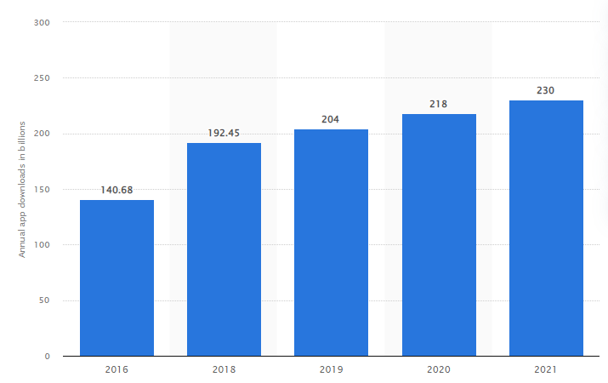
Figure 1: Number of app downloads from 2016 – 2021 (Annual Mobile App Downloads Worldwide by Store 2026 | Statista, 2021).

In 2021, more than 230 billion mobile applications were downloaded worldwide. The number of downloads and the financial returns encourage businesses to use advanced automation technologies to remain competitive. A white paper by Telit titled “How to Leverage Smart Meter Opportunities with Future-Proof Designs” states that mobile apps were an opportunity for increased customer engagement because they create a portal for two-way communication (Telit, 2018). According to Telit, power utility companies can create mobile applications to help consumers better understand (and participate in) demand response programs.

Mobile Application Platforms
A mobile platform is an operating system designed and installed on mobile devices to allow various software applications and services to run on those devices. There are over 3 billion mobile devices that are currently in use today, and the major platforms on which these devices work are Android, iOS, and Windows (M. Singh & G, 2021). However, the Windows Mobile platform, developed by Microsoft, was discontinued in 2017.

iOS Mobile Platform
iOS is the operating system designed for Apple’s devices, such as iPhone, iPad, and iPod. The operating system supports input through direct manipulation and responds to various user gestures, such as pinching, tapping, and swiping (Posey, 2024). iOS supports Objective-C, C, C++, and Swift programming languages, and it is the second most widely used mobile platform, after Android (Rahul, 2024). A mobile application built for use on Apple’s iOS is available on the Apple App Store and crafted to run on Apple’s iOS mobile operating system.

Android Mobile Platform
Android is a Google-led open-source operating system developed by the Open Handset Alliance, an alliance of prominent companies that includes Google, HTC, Motorola, Texas Instruments, and others (Rouse, 2011). The Android platform runs on a Linux kernel, which allows for a more open and customizable operating system while ensuring that mobile applications are running in a secure environment. Android uses an open-source programming language called Java. Google has also adopted Kotlin as an alternative programming language for Android development, but Java continues to be the primary programming language. Table 1 is a neck-to-neck comparison of the two most popular operating systems for mobile phones and tablets.

Table 1: Android mobile platform versus iOS
Platform | Android | iOS
Developer | Google | Apple
App Store | Google Play | App Store
Open Source | Yes | No
Kernel | Linux | iOS kernel-based Darwin OS
Programming Languages | Java | Objective-C, C, C++, and Swift
Available Languages | 100 + | 40
Customizable | Yes | No
Supported Devices | Huawei, Samsung, LG, Sony, Google, and many more | Apple devices
Supported standards | Global System for Mobiles (GSM) and Code Division Multiple Access (CDMA) | GSM and CDMA
Security | Monthly security updates | Occasional security updates because iOS is locked. Rare security threats

Android is the most used smartphone platform. The Android market share currently represents 74.13% of the global mobile operating market (Ivan, 2022). Android Development Studio is the official Integrated Development Environment (IDE) for Android application development (Barcia, 2022). The blog also states that the development studio offers advantages such as a flexible Gradle-based build system, rich layout editor, code templates for common app features, and lint tools to catch performance, usability, and version compatibility.

Visual Studio Code, or VS Code, is another mobile application development environment that runs on Windows, macOS, and Linux. VS Code is a lightweight and powerful tool with extension support for several programming languages and frameworks, including Flutter, Dart, Python, C++, Java, C#, PHP, and Go. For this study, VS Code supported source-code editing, debugging, and emulator-based testing for the Android mobile platform.

Mobile Application Vulnerabilities
Mobile applications have become a prime target of cybercrime. This is because of the sensitive data they process (Sachdeva, 2022). A blog by Harshit Agarwal points to the explosive rise in the market for smartphones, making it the largest attack surface footprint for hackers. The blog also states that hackers target unprotected mobile devices and use them to gain access to corporate networks (Agarwal, 2021).

In January 2021, Nissan North America suffered a data leak when the source code of its mobile application emerged online after the company misconfigured one of its Git servers (Agarwal, 2021). Git is an open-source distributed version control system that maintains documents, or any type of file, on a computer with speed and efficiency. According to Agarwal, another mobile application (ParkMobile) was attacked in April 2021. The attack was only discovered when it was found that the account information of its 21 million consumers was being sold by someone illegally. The data included customer email addresses, phone numbers, date of birth, hashed passwords, license plate numbers, and mailing addresses. According to ParkMobile, the encrypted passwords were accessed, but not the encryption keys required to read them, as the company uses an advanced hashing algorithm called Bcrypt, which is difficult to crack.
In August 2022, Seesaw, which is a popular messaging app for parents and teachers in the United States of America (USA), was hacked when some parents received messages and an image of a man engaged in an explicit act (Collier, 2022). The image was sent by the mobile application as links to Bitly, a popular link-shortening service that obscures actual web addresses. According to Seesaw officials, the hacker or hackers gained access to individual user accounts using a credential-stuffing attack. An attack whereby hackers look through previous data breaches to identify combinations of usernames and passwords.

There are a lot of vulnerabilities that hackers can exploit in a mobile application. Figure 2 lists the top 10 security threats compiled by the Open Web Application Security Project (OWASP), a non-profit foundation that works to improve the security of software.

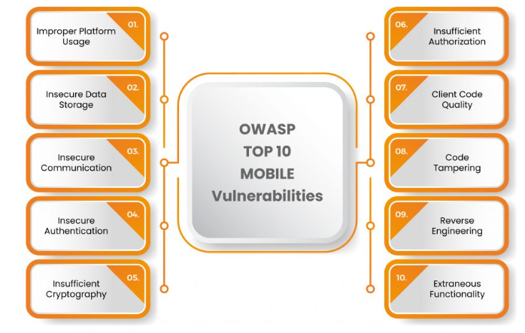
Figure 2: OWASP Top 10 Mobile Vulnerabilities (Sachdeva, 2022)

The OWASP’s top 10 list includes vulnerabilities such as improper platform usage, insecure data storage, insecure authentication, and insufficient cryptography. Mobile application developers can use this list when testing their applications. The list is explained in more detail below:

      - Improper Platform Usage refers to developing a mobile application that contradicts the best practices when it comes to security control or misuse of an operating system feature.
      - Insecure Data Storage refers to the security level of where the data is being kept, be it on servers, mobile devices, or cloud storage.
      - Insecure Communication refers to sending sensitive information via insecure channels. Developers can use encryption to ensure that data transmitted over a network cannot be accessed by those who are not authorised to do so.
      - Insecure Authentication refers to weak passwords that allow attackers to gain access to the mobile application or the backend server employed by the application.
      - Insufficient Cryptography refers to using cryptographic algorithms that are known to be weak, such as the Data Encryption Standard (DES).
      - Insufficient Authorization refers to the situation when an application does not prevent a user or an entity from accessing functionality that violates the security policy.
      - Client code quality refers to mitigating the security risks associated with poor code quality.
      - Code Tampering is the process whereby hackers or attackers make an unauthorised modification or alteration of source code during mobile application development, testing, or deployment.
      - Reverse engineering is the process of analysing mobile applications to understand their source code.
      - Extraneous Functionality refers to functions hidden inside a mobile application that an attacker can exploit.

A 2024 blog by Shikhil Sharma states that poor coding and weak security protocols put user data at risk and should be addressed (Sharma, 2024). Sharma lists malware attachments, data leakage, everyday API (Application Programming Interface) threats, insecure credential storage, code tempering, unprotected network traffic, phishing attacks, weak server-side security, unpatched software, rogue mobile apps, insufficient testing, unrestricted file uploads, and poor encryption practices, absence of Multi-factor Authentication (MFA), and improper session handling as several risks that tend to undermine mobile application protection best practices.

Mobile Applications Secure Features
According to Kaspersky, cybersecurity or information security is the practice of defending computers, servers, mobile devices, electronic systems, and data from malicious attacks (Kaspersky, n.d.). There are several security considerations for mobile applications. The Android developer website, a site that contains the latest app development tools, platform updates, training, and documentation for developers across every Android device, lists several security guidelines. Table 2 summarises the security guidelines as indicated on the Android developer website (Developers, 2024).

Table 2: Android Security Guidelines
Guidelines | Description
Authentication | Helps control access to protected assets like user data, app functionality, and other resources.
App Integrity | Helps you check that interactions and server requests are coming from your genuine app binary running on a genuine Android-powered device.
Data Storage | Depending on the type of storage (Internal storage, External storage, or content providers), consider using a content provider that offers read and write permissions to other applications if you want to share your data.
PermiSsions | Restricting access to sensitive permissions reduces the risk of inadvertently misusing those permissions, improves user adoption, and makes the app less vulnerable.
Networking | Implement all best security practices when the device performs network transactions, such as using the appropriate protocols (HttpsURLConnection) for sensitive data.
Input Validation | Use type-safe languages to reduce the likelihood of input validation issues.
User data | The best approach for user data security is to minimize the use of APIs that access sensitive information.
WebView | Limit the capability of WebView to the minimum functionality required by your application to avoid common web security issues, such as cross-site scripting (JavaScript injection).
Credential request | Minimize credential exposure (Avoid unnecessary credential requests) and use secure authentication (Implement passkeys)

Secure mobile application authentication can be achieved in different ways, such as biometrics or MFA. MFA is used to address insecure authentication by adding an extra layer of security that uses technology such as Email or Short Message Service (SMS) to send a unique code that a user would need to proceed with the logon. A blog by Melanie Maynes, Senior Product Marketing Manager at Microsoft Security, states that an account is more than 99.9% less likely to be compromised if you use MFA (Maynes, 2019). MFA requires users to present at least two types of authentication, and this can lead to what is known as MFA fatigue. A situation in which users get annoyed and frustrated when constantly entering additional login credentials. As a result, some software application requires only Two-factor Authentication (2FA). 2FA is a subset of MFA, whereby, in addition to the password, only one additional level of security is added (Mohanakrishnan, 2022). 2FA requires users to verify their identity either by using biometrics, entering a token, or a one-time password (OTP) received via SMS or email, as shown in Figure 3.
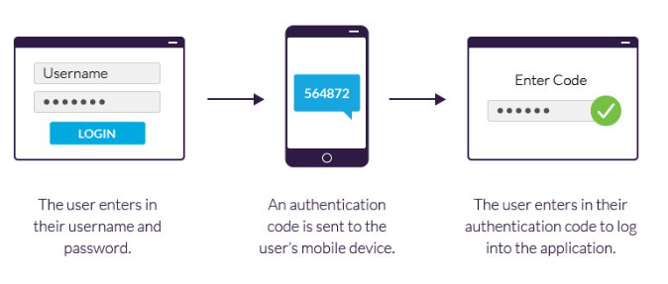
Figure 3: 2FA Process (Imperva, n.d.)

There are different types of 2FA APIs available for mobile application developers. For instance, SMS APIs such as Authy, Verify, FortyTwo, Curity Authentication Service, Identity Automation, and OneLogin (Simpson, 2019). APIs are also available for input validation. The email verification API is designed to automatically detect if email addresses are valid, fake, disposable, or mistyped. This helps ensure that email communication reaches the intended audience.

Mobile application communication can be encrypted to prevent cyberattacks. This is accomplished by using strong confidentiality algorithms such as AES-GCM-256 or ChaCha20-Poly1305 and by using digital signature and hashing algorithms such as RSA (Rivest–Shamir–Adleman) and SHA-256 (Secure Hash Algorithm 256-bit) to validate the authenticity and integrity of the data.

Advanced Encryption Standard (AES) is a symmetric block cipher algorithm that was established by the National Institute of Standards and Technology (NIST) in 2001 to replace the Data Encryption Standard (DES) algorithm that was known to be vulnerable because of its small key size (Salkanovic, A., Ljubic, S., Stankovic, L., Lerga, J. (2021)). The algorithm, also known as the Rijndael algorithm, has a block size of 128 bits that are encrypted using bit key sizes of either 128, 192, or 256 bits that are passed as arguments to create a secret key. This secret key is used for both encryption and decryption. Baibev Kumar Jena describes the features of AES as follows (Jena, 2023):

- SP Network: It works on a substitution-permutation (SP) network structure rather than a Feistel cipher structure, as seen in the case of the DES algorithm.
- Key Expansion: It takes a single key up during the first stage, which is later expanded to multiple keys used in individual rounds.
- Byte Data: The AES encryption algorithm does operations on byte data instead of bit data. So, it treats the 128-bit block size as 16 bytes during the encryption procedure.
- Key Length: The number of rounds to be carried out depends on the length of the key being used to encrypt data. The 128-bit key size has ten rounds, the 192-bit key size has 12 rounds, and the 256-bit key size has 14 rounds.

The main advantage of AES is the faster encryption and decryption times, as only one key is required to encrypt and decrypt the data. This secret key needs to be securely shared with everyone involved in the communication because anyone with access to the key can read the encrypted data.

ChaCha20 is another symmetric encryption algorithm developed by Daniel J. Bernstein that uses a 256-bit key to encrypt and decrypt data (Nagaraj, 2023). Nagaraj describes the ChaCha20 encryption process as follows:
- The ChaCha20 algorithm generates a 256-bit key from a user-supplied key and a randomly generated 96-bit nonce.
- The algorithm uses the key and nonce to initialize the state of the cipher.
- The algorithm then encrypts each block of data using the state of the cipher, which is updated after each block.
- The encrypted data, or ciphertext, is produced by XORing the plaintext with the output of the block encryption step.

Transport Layer Security (TLS) defines the new Authenticated Encryption with Associated Data (AEAD) by combining the ChaCha20 cipher with Poly1305 for a MAC (Message Authentication Code) for additional security. The Poly1305 authenticator algorithm was also developed by Daniel J. Bernstein. Poly1305 algorithm is a one-time authenticator using a 32-byte one-time key and an arbitrary-length message to obtain a 16-byte message authentication code (Serrano, R., Duran, C., Sarmiento, M., Pham, C., Hoang, T. (2022)).

In comparison, Rivest–Shamir–Adleman (RSA) is an asymmetric algorithm developed in 1977 by Massachusetts Institute of Technology (MIT) colleagues Ron Rivest, Adi Shamir, and Leanard Adleman that uses two different key pairs for encryption and decryption. RSA supports key lengths of 1024, 2048, 3072, 4096, 7680, and 15360 bits. Figure 4 is a high-level representation of how RSA works.

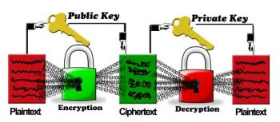
Figure 4: How RSA Encryption Works (Nisha & Farik, 2017)

The recipient generates a public and private key pair. The recipient shares the public key with the sender. The sender encrypts the message using the recipient's public key. The recipient then uses their private key to decrypt the message. The algorithm is very secure as it uses large prime numbers to make it difficult to decrypt the message, and is popular in online banking and e-commerce applications. However, the use of large prime numbers during encryption increases the key size and the processing time. This makes it slower than other encryption algorithms.

The SHA-256 algorithm is a cryptographic hash function developed by the National Institute of Standards and Technology (NIST) that is used in digital certificates as well as in data integrity (Rachmawati, 2018). A blog by Josh Lake describes that SHA-256 involves 64 rounds, results in a 256-bit hash, and has a 512-bit block size (Lake, 2022). The paper also states that the message input is processed in 32-bit words, while the initialization variables and constants are also 32-bits in length. Below is a summarized overview of the process:

- The first step in the SHA-256 process is to split the input message into fixed-sized blocks. In the case of SHA-256, the blocks are 64 bytes (512 bits) in size.
- The block is padded to ensure that it is a multiple of 512 bits in size, and this padded block is split into 16 32-bit words. The block is then processed through a series of mathematical operations to produce an updated intermediate hash value.
- The intermediate hash values are combined to make the final hash value.

The SHA-256 algorithm is involved in many security protocols we use today, such as Transport Layer Security (TLS), Internet Protocol Security (IPSec), and Secure Shell (SSH). The algorithm is a fast, reliable, and widely used hashing protocol in the world.

In addition to encryption, mobile application developers are encouraged to consider using security frameworks and penetration testing tools. These tools are used to analyze mobile application security vulnerabilities. Table 3 contains a list of a few mobile application security tools and frameworks.

Table 3: Tools and Framework (Sachdeva, 2022)
Tools and Framework | Description | Drawback
Dex2jar | Transforms bytecode from the .dex format of an APK to classes.jar to view the source code of an Android application. | Difficult to add new meters and devices later
Java De-compiler (JD- GUI) | Java code is rendered as Java class files by this program, making it readable. | The Ethernet connection is not encrypted.
Akptool | Open-source tools for decompiling binary closed and third-party Android apps. | Data signals often encounter interference from the electrical current running.
Apk Analyzer | File sizes and their proportional percentage of the total APK size are provided to the file’s browser by the APK Analyzer. | Need a gateway to convert the data to TCP/IP

These tools and frameworks can be used for penetration testing and reverse engineering. Penetration testing is a simulated cyber-attack against a network or a computer system, used to check for vulnerabilities, while reverse engineering is the process of analysing software applications to understand their source code. A combination of these testing tools can be used to ensure that all exploitable vulnerabilities are detected and addressed.

Smart Energy Meters
Smart meters are IoT devices that measure and transmit data about electricity consumption to power companies using sensors (Garcia, 2021). In comparison to conventional energy meters, smart meters have advantages such as bi-directional communication and automatic meter readings, meaning no more estimated billing (Campion, 2022).

A 2020 article from Power and Beyond talks about how IoT-type intelligence will allow operators to visualize and manage their smart grids reliably and efficiently (Charig, 2020). The article also talks about smart metering, allowing customers to see how much energy they are using, when they are using it, and its costs. Smart meters typically transmit data to a local smart meter gateway, which aggregates data from all meters and then forwards it to the cloud, where providers and customers can access it through a platform, as shown in Figure 5 (Garcia, 2021a).
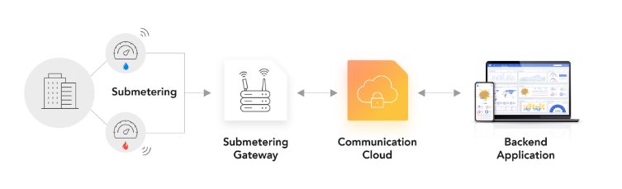
Figure 5: Typical Smart Meter Communication (Garcia, 2021a)

By using Ethernet or Wi-Fi, smart meters can use TCP/IP (Transmission Control Protocol/Internet Protocol) to communicate with the gateway and vice versa. Table 4 contains information about the different types of protocols.

Table 4: Smart Meter Communication Protocols (Garcia, 2021a)
Task | Description | Drawback
Wired protocols | Deploying the cable or wiring upfront for smart meter communication (hardwired connections) | Difficult to add new meters and devices later
Ethernet | Use TCP/IP or User Datagram Protocol/IP to send data. | The ethernet connection is not encrypted.
Power Line Communication | Simply option, but unorthodox | Data signals often encounter interference from the electrical current running.
Meter Bus (M-Bus) | A European standard that’s already widely used in buildings and was specifically developed for smart meters | Need a gateway to convert the data to TCP/IP
Wireless Protocol | Smart meters can use TCP/IP or UDP/IP to transmit via Customers Wi-Fi | Short range  Poor penetration  uses the unlicensed 2.4GHz frequency band
Wireless Meter-Bus | Wireless M-Bus operates on three sub-GHz different frequencies | Only in Europe  Need a gateway to convert the data to TCP/IP
LoRaWAN | A popular LPWAN (Low-Power-Wide-Area-Networks) solution with widely available networks in 25 countries | Only supported by 25 countries  No Roaming
MIOTY | Uses telegram splitting to divide data into subpackets, and then transmits the packets at different times and frequencies. | Very new  Not supported by many devices
Ethernet/DSL (wired) | DSL (Digital Subscriber Line) uses telephone lines via TCP/IP or UDP/IP
Zigbee | Zigbee is a mesh network topology to connect devices and extend coverage | uses the unlicensed 2.4GHz frequency band
Cellular (wireless) | Using SIM cards, like cell phones and different types of cellular networks example 2G, 3G,4G,5G, LTE-M and NP-IoT

Smart meters use both wired and wireless protocols for communication. Wired protocols include hardwired connections such as Ethernet, Power Line Communication (PLC), and Meter-Bus (M-Bus). Whereas wireless protocols include Cellular networks (GPRS, 4G, 5G, LTE-M), Wireless Meter-Bus, and Low-Power-Wide-Area-Networks (LoRaWAN). A wireless meter bus is a wireless version of the M-Bus standard and is mostly found in Europe. In Namibia, optical Fiber or mobile phone networks such as 4G or General Packet Radio Services (GPRS) have made it possible to control smart meters remotely with improved response time due to their high bandwidth throughput.

NamPower uses Landys+Gyr smart meters. The smart meters support the International Electrotechnical Commission (IEC) 60870-5-104 standard for communication. Founded in 1906, IEC is a global international standards organization that prepares and publishes International Standards for all electrical, electronic, and related technologies (IEC, 2024). These standards provide instructions, guidelines, rules, or definitions that are used to design, manufacture, install, test & certify, maintain, and repair electrical and electronic devices, and systems. A technical report by Pert Matousek describes IEC 60870-5-104 as a standard for telecontrol equipment and systems with coded bit serial data transmission in Transmission Control Protocol/Internet Protocol (TCP/IP) based networks for monitoring and controlling geographically widespread processes (Matousek, 2017). The coded bits comply with the OBIS (OBject Identification System ) standard. The OBIS code is defined and allocated by the DLMS (Device Language Message Specification) user association and is used as the logical names of data objects in energy metering equipment. Table 5 shows the hierarchical structure of the OBIS code, while Table 6 is an example of how meter reading software translates the OBIS code (Verma, 2023).

Table 5: OBIS code
Group | Description | Examples
A | Medium | 0= Abstract Objects, 1=Electricity, 7=Gas, 8=Water
B | Channel | 0 = no channel available
C | Physical Value depends on A | Current, Voltage, Energy (3 phase Active Power)
D | Identifies types, depends on A and C | maximum, current value, energy, according to various specific algorithms
E | Tariffs | 0 = total, 1 = tariff 1, 2 = tariff 2
F | Identifies historical data, depends on A - E | Billing periods, 255 = Not used

Table 6: Example of OBIS Code Translation
Parameters | OBIS Code | Value
Total Active Power | 1.0.1.7.0.255 | 140 VA
Total Reactive Power | 1.0.3.7.0.255 | 140 W
Total Apparent Power | 1.0.9.7.0.255 | 0 Var

Total Active Power is the power that is used by the customer, while Total Reactive Power is the power generated but has not been converted to active power, unused power. Lastly, the Total Apparent Power is the total power generated, active power plus reactive power.

IoT for Smart Energy Meters Vulnerabilities
An article titled “Cyber-attack crisis management in the context of energy companies” states that the critical nature of operations in the energy industry makes them particularly enticing targets for cybercriminals and hackers, all driven by the desire to exploit these weaknesses to inflict considerable damage (X). The article further categorises DoS, phishing, password attacks, malware, and ransomware as the most common types of attacks.

In 2010, the Natanz nuclear facility in Iran was attacked by malware named Stuxnet (XXX). According to the article, the malware was specifically constructed to sabotage centrifuges and damage critical infrastructure by exploiting Siemens Supervisory Control and Data Acquisition (SCADA) systems. Stuxnet manipulated centrifuge frequencies, causing them to speed up and slow down until they failed. On December 23, 2015, Ukrainian power companies experienced unscheduled power outages impacting a large number of customers (XXX). A malware called BlackEnergy was deployed to access remote administration tools at the operating system level or a remote industrial control system (ICS) to manipulate electric utility operations to produce an outage, followed by a disruptive attack to delay recovery.

David Garcia stated that hacking smart meters could cripple the key infrastructure of a large organization (Garcia, 2021b). Therefore, smart meter communication must be transmitted securely to avoid a MiTM attack. This cyberattack exploits the IoT architecture by intercepting communication between two parties, often stealing login credentials or personnel information, spying on the victims, sabotaging communication, or corrupting data (Swinhoe, 2022). In a MiTM attack on smart meters, an attacker can tamper with meter readings, which can result in financial losses for both utilities and customers.

The IoT architecture depends on its functionalities. In most cases, it consists of three layers, namely, the perception layer, the network layer, and the application layer. All these layers work collaboratively to transmit data and are vulnerable to multiple attack vectors, as shown in Figure 6.

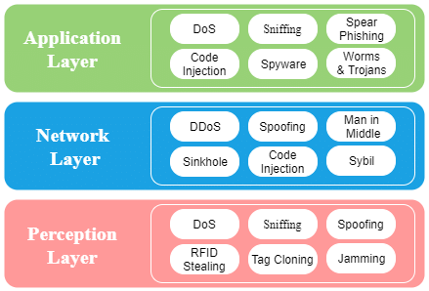
Figure 6: IoT Attack Vectors

The perception layer is the physical layer that has sensors for gathering information and is vulnerable to attacks such as Denial of Service (DoS), sniffing, and jamming. The network layer is responsible for connecting and transporting data between devices. This layer is vulnerable to Man-in-the-Middle and spoofing attacks. The last layer is the presentation layer, which is responsible for providing application-specific services to the end user and is vulnerable to worms, trojans, spyware, and code injection attacks.

There are vulnerabilities in the communication protocols used by smart meters. According to an article by Petr Matoušek, the IEC 104 communication protocol has security issues (Matoušek, 2017). The article states that IEC 104 is like the Simple Network Management Protocol (SNMP), whereby the SNMP manager sends short commands to the SNMP agents to retrieve their values. However, unlike SNMP, the IEC 104 does not define any security as access passwords, authentication (using RSA), or encryption (using SHA).

The following are the possible attacks on the IEC 104 communication protocol:

- Changing the value of the Application Service Data Unit (ASDU) transmitted over in the IEC packet.
- Inserting a spoofed ASDU message into the network
- Distributed Denial-of-Service (DDoS) attack on IEC 104 master or slave stations.
- Inserting a rogue control station into the network
- Interception of the transmitted data.

Smart Meters Secure Features
Despite their huge benefits, and just like any other connected device, smart energy meters pose significant cybersecurity risks. Smart energy meters collect and transmit a large amount of sensitive data, as a result, they can be targeted by hackers. Therefore, it is extremely important to secure smart energy meters. A blog by Neil Bosworth lists the following five (5) principles to consider when securing a smart meter infrastructure (Bosworth, 2022).

- Automatic risk or threat assessment at the beginning of a project to meet regulations.
- Implementing strong trusted IDs in the core of connected meters.
- Encrypted data send from smart meters to ensure confidentiality.
- Ensure that data exchange is done between trusted entities via digital mutual authentication.
- Implement a strong lifecycle management process whereby assets and credentials are always updated via secure, remote updates using digital signatures.

Smart energy meters can also be protected by firewalls. A firewall is a network device that monitors and filters incoming and outgoing network traffic based on a defined set of security rules. Firewalls are placed between a corporate network and an external network such as the Internet and depending on their types, they provide different ways of traffic management based on indicators such as traffic type, sender address and ports, receiver addresses and ports, conditions, and connection state (Hasanalizadeh-Khosroshahi & Shahinzadeh, 2016).

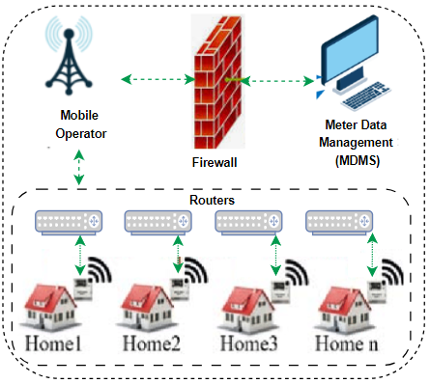
Figure 7: Firewall and Smart Meters

Firewalls are the first line of defence in network security, as shown in Figure 7. Firewalls protect against external threats by shielding your computer or network from malicious network traffic. Similarly, dedicated IP addresses can be assigned to the energy meters, and a firewall can be configured to block traffic from certain locations, applications, or ports while allowing relevant and necessary traffic to go through. However, external firewalls can only defend the network against outside threats. Therefore, they must be complemented by internal security measures.

Cybersecurity Framework
Framework or Standards are represented as documents that define the specifications, procedures, and guidelines, aiming to ensure the safety, consistency, and reliability of products, services, and systems(Taherdoost, 2022). Benchmarking your security controls against an established framework ensures your organization adopts industry-recognized best practices, which leads to a more proactive, consistent, and resilient security posture. Table 7 lists the top 11 cybersecurity frameworks in 2024 according to a blog by Jay Ryerse (Ryerse, 2024).
Table 7: Top 11 Cybersecurity Frameworks
Framework | Description
NIST | NIST’s Cybersecurity Framework guides industry, government agencies, and other organizations to manage cybersecurity risks.
ISO 27001 and 27002 | These standards provide a comprehensive framework for organizations looking to protect their data through robust policies and best practices.
CIS Controls | The Center for Internet Security (CIS) Control is a set of best practices for cybersecurity to help organizations prioritize and implement essential security measures effectively. This framework includes 20 controls, covering many areas of cybersecurity, including access control, asset management, and incident response.
SOC2 | The Service Organization Control (SOC) framework is an auditing standard used by third-party auditors to assess the security, availability, processing integrity, confidentiality, and privacy of a company’s systems and services.
PCI-DSS | The Payment Card Industry Data Security Standard (PCI DSS) framework includes 12 requirements organizations must meet to secure their systems and prevent unauthorized access to customer information. These requirements cover access control, network security, and data storage specific to the payment processing industry.
COBIT | Control Objectives for Information and Related Technologies (COBIT) is a framework for the governance and management of enterprise IT. The COBIT framework is divided into five categories: Plan & Organize, Acquire & Implement, Deliver & Support, Monitor & Evaluate, and Manage & Assess. COBIT offers best practices for governance, risk management, and cybersecurity.
HITRUST Common Security Framework | The Health Information Trust Alliance (HITRUST) Common Security Framework (CSF) is a certifiable framework that provides organizations with a comprehensive approach to regulatory compliance and risk management designed for the healthcare industry. This standard includes best practices for protecting the security of patient data, covering areas such as access control, identity and access management, encryption, audit logging, and incident response.
Cloud Control Matrix | Cloud Control Matrix (CCM) is a comprehensive cybersecurity framework for cloud-based systems and applications that covers access control, user authentication, encryption, audit logging, and incident response.
CMMC 2.0 | Cybersecurity Maturity Model Certification (CMMC) 2.0 was designed to protect United States national cybersecurity information by creating a set of consistent cybersecurity standards for any organization working with the Department of Defence (DoD).
Essential 8: | Essential 8 is Australia’s baseline cybersecurity framework that all organizations are recommended to follow. It serves as a baseline set of minimum best practices to avoid compromised systems. The mitigation strategies that constitute the Essential Eight are patch applications, patch operating systems, multi-factor authentication, restricted administrative privileges, application control, restricted Microsoft Office macros, user application hardening, and regular backups.
Cyber Essentials: | Cyber Essentials is the UK’s primary framework built around five main technical controls designed to protect against the most common cyberattacks. The five cyber essentials controls are firewalls and routers, secure configuration, access control, malware protection, and patch management.

The cybersecurity frameworks are designed for different environments and requirements. It is important to look for a framework that aligns with your goals and obligations. NamPower is currently in the process of aligning the company’s security strategies with the NIST-CSF to reduce the chances of security incidents and build a durable security infrastructure for the future. NIST: NIST’s Cybersecurity Framework guides industry, government agencies, and other organizations to manage cybersecurity risks (National Institute of Standards and Technology, 2024). The framework was created in 2014 as guidance for federal agencies, but the principles apply to almost any organization seeking to build a secure digital environment.

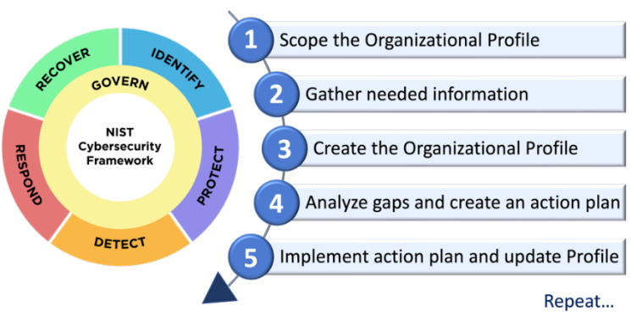
Figure 8: NIST-CSF (National Institute of Standards and Technology, 2024)

In 2024, NIST unveiled the Cybersecurity Framework 2.0 (CSF 2.0). NIST CSF 2.0 extends its reach beyond critical infrastructure cybersecurity, considering Small and Midsized Businesses (SMBs) with modest or no cybersecurity plans currently in place. Moreover, the cybersecurity framework now encompasses six core functions — 1. Identify, 2. Protect, 3. Detect, 4. Respond, 5. Recover, and 6. Govern, as shown in Figure 8, provides a holistic approach to managing cybersecurity risk.

Research Gap
The aspiration to innovate the prepaid energy system started a long time ago. For instance, a study conducted by (Jubi. K, Mareena John) titled “Prepaid Energy Meters with GSM Technology,” concluded that Smart Energy meters using GSM technology can enable users to pay for electricity before its consumption. The study also stated that power utility companies can take advantage of the GSM infrastructure to request and retrieve power consumption, thus removing human operators who are prone to errors. Another study titled “Modelling of GSM-Based Energy Recharge Scheme for Prepaid Meter” concluded that it was more convenient for consumers to recharge their energy meters using cellular networks (Omijeh & Ighalo, 2013). However, the proposed GSM-based Rechard System (GBRS) was designed to enable the power utility companies to recharge the prepaid meters remotely and not the users (consumers).

More recently, a South African company called Prepaid24 launched a mobile application that enables customers to reload electricity from anywhere at any time (Mzekandaba, 2014). The mobile application had features such as a reminder to purchase electricity, tariff structures, and consumption graphs. However, there was no direct communication between the mobile application and the energy meter, meaning customers had no real-time meter data, and they had to manually enter the token values after purchasing electricity. Similarly, Australia has a mobile application called Powershop that has features such as tracking electricity usage in costs per day, or the total kilowatt hour (kWh) used per day, and receiving notifications of energy bill due dates (Mullane, 2021). However, the blog states that the app does not allow customers to interact with their energy meters.

While numerous studies have focused on enhancing prepaid energy systems through technologies such as GSM, and others have independently examined IoT technologies for smart prepaid meters, relatively few have investigated the end-to-end cybersecurity implications of integrating these solutions. This gap underscores the significance of the present study, particularly for traditional utility companies in developing countries that continue to rely on aging infrastructure and legacy systems for their operations.

Summary
During the implementation phase, the prototype mobile application and its supporting backend services were developed from the requirements and design artefacts. The work included preparing the database, configuring the cloud server, deploying the MQTT broker, connecting the smart meter data flow, sketching the user interface, implementing the Android-facing mobile application, and defining the API interactions used for authentication and email verification. The chapter also described the functional, security, and performance tests used to evaluate whether the prototype met the study objectives.

Research Methodology

Overview
Research methodology is the path through which researchers formulate their problem and objective, and present their results from the data obtained during the study period (Sileyew, 2019). The objective of this study was to identify the existing threats to mobile applications and IoT technologies and design a secure mobile application for smart energy meters. This was to automate the prepaid electricity system in Namibia, subsequently optimizing business processes and improving customer satisfaction. This chapter presents the methods that were employed in this study to obtain the desired results. We begin by discussing the various types of research paradigms and the research design approach. This was followed by population sampling and an overview of how the collected data will be analysed. The chapter concludes by discussing the preferred project management model for mobile application development.

Research Paradigm
According to Filstead (1979), a research paradigm is defined as a ‘set of interrelated assumptions about the social world which provide a philosophical and conceptual framework for the organized study of that world’. Professor Charles Kivunja describes a research paradigm as the conceptual lens through which the researcher examines the methodological aspects of their research project to determine the research methods that will be used and how the data will be analysed (Kivunja & Kuyini, 2017). The word paradigm originated from the Greek word paradeigma, which means pattern. In educational research, the term paradigm is used to describe a philosophy that influences how a chosen study can be conducted. Professor Charles Kivunja further suggests that research paradigms consist of four pillars or components, namely Ontology, Epistemology, Methodology, and Axiology. Ontology is the philosophical theory regarding reality, “What is the reality” and Epistemology is the study of knowledge, “How can we know the reality”. The Methodology paradigm is described as the general concepts and procedures that prove the validity of the knowledge gained “How do we discover the reality” whereas Axiology refers to the ethical issues that need to be considered when planning for a research proposal “What is the expected ethical behaviour”.

The four most broadly applied research paradigms include pragmatism, positivism, interpretivism, and post-positivism(Kankam, 2019). Pragmatism as a paradigm is based upon the premise of utilizing the best methods to investigate real-world problems, this allows the use of multiple sources of data and knowledge to answer research questions (Allemang et al., 2022). Pragmatists believe that no two people have identical experiences, so their worldviews can also not be identical (Kaushik & Walsh, 2019). Therefore, there is no single point of view (one way or nothing) as there are multiple realities. However, there are always varying degrees of shared experiences between any two people that lead to different degrees of shared beliefs. Positivism is aligned with the hypothetico-deductive model of science that builds on verifying a priori hypotheses and experimentation by operationalizing variables and measures (Park et al., 2020). That is to say that positivism believes that only knowledge gained through observation, including measurements, is trustworthy. Here, the researcher is limited to data collection and objective interpretation of that data. Post-positivism rejects the notion that a researcher can be an independent observer of the social world in favour of the assumption that reality is multiple, subjective, and mentally constructed by individuals. This means that a researcher’s background can influence what they observe and therefore impact what they conclude.

Interpretivism was developed through a critique of positivism, with a perspective that reality is subjective, multiple, and socially constructed (Alharahsheh & Pius, 2020). The paper further states that interpretivism considers humans to be different from physical phenomena, and the two should not be explored similarly. Therefore, social sciences research requires this distinction and should be different from natural sciences research, as one can only understand someone's reality through their experience of that reality, which may be different from another person's, shaped by the individual's historical or social perspective.

Every research project employs a particular paradigm as such, this study has adopted the design-based research paradigm. Design-Based Research (DBR), sometimes known as design experimentation, is a methodological approach that aligns with research methods from the fields of engineering or applied physics, where products are designed for specific purposes (Scott et al., 2020). Design-based research is one of the most exciting evolutions in research methodology, as it allows for the potential knowledge gained through the intimate connection designers have with their work to be combined with the knowledge derived from research (Christensen & West, n.d.). Scott, Wenderoth, and Doherty further state that with design-based research, the researchers first identify a problem that needs to be addressed. They then design a potential “solution” to the problem in the form of instructional tools and then test these tools in a real-world setting to see if the tools positively impact student learning. Finally, the researchers reflect on the outcomes of the experiment, identifying the features of the instructional tools that were successful, revising those aspects that were not helpful, and determining how the research informed the theory underlying the experiment. This is done through an iterative process as shown in Figure 8.

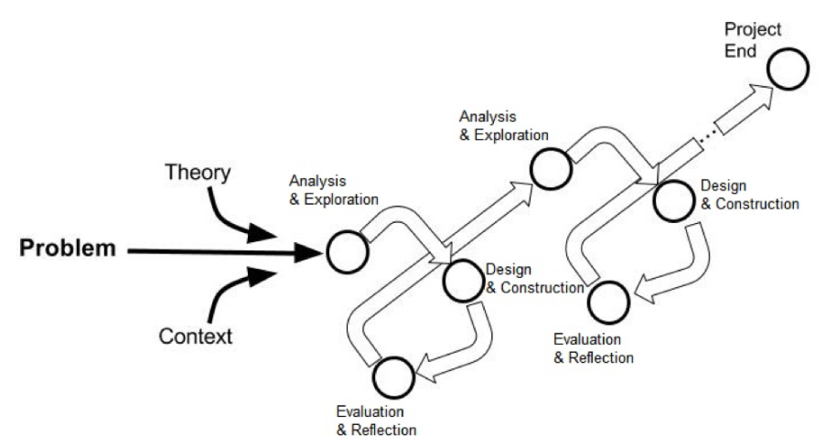
Figure 9: The Iterative Process of Design-Based Research (Armstrong et al., 2020)

Armstrong, Dopp, and Welsh describe the iterative process of design-based research from the analysis and exploration, through design and construction, to evaluation and reflection (Armstrong et al., 2020). The Analysis and Exploration phase is used throughout the entire process, as it is critical to define and understand the problem to be addressed. Design and Construction lay out a variety of options to use when designing the solution. Finally, the Evaluation and Reflection allow the researchers to assess the designs both before and after usage.

Research Design
Research design is the plan or framework used to conduct a research study(S. Singh, 2023). It involves outlining the overall approach and methods that will be used to collect and analyse data in order to answer research questions or test hypotheses. A good research design enables you to collect accurate and reliable data to draw valid conclusions. The purpose of this study was to design a secure mobile application for smart prepaid energy meters in Namibia. The research approach adopted for this study was the design-based paradigm, which was complemented by a mixture of both quantitative and qualitative research methodologies. Quantitative research is the process of objectively collecting and analysing numerical data to describe, predict, or control variables of interest, whereas qualitative research is the process of collecting, analysing, and interpreting non-numerical data (McLeod, 2023). Examples of quantitative data collection methods are probability sampling, surveys, polls, questionnaires, and observations, while qualitative data collection methods are interviews (structured or unstructured), observations, and journals.

Data Collection
An article from the Iterators defines data collection as a systematic method of obtaining, observing, measuring, and analysing accurate information to support research conducted by groups of professionals, regardless of the field where they belong (Data Collection: Best Methods + Practical Examples | Iterators, 2021). In this research, data will be collected from existing mobile applications, mobile application testing tools, and IoT devices such as Smart Energy Meters. Literature from an existing mobile application for smart prepaid energy meters will be reviewed to understand how they were designed, along with the security frameworks that were used. An experiment will also be carried out on these technologies to determine their level of usability and security.

A qualitative approach will be used to understand the user’s opinions, attitudes, and experience with the mobile application. Interviews will be conducted with the relevant stakeholders, such as power utility companies and their customers. The main objective of the interview is to understand how the end-users feel as they operate the mobile application. The following questions formed part of the interviews.

- Which features do you like most about the mobile application?
- Which features do you like the least about the mobile application?
- Which other features do you feel are missing from the application?
- How is the navigation of the mobile application?
- When do you think this mobile application will be most useful?
- How likely are you to recommend the mobile application to a friend?
- Where do you think the mobile application needs improvements?

Quantitative methodology will be used to collect data from mobile application penetration testing tools and frameworks. Table 3 consists of the most common mobile application testing frameworks according to a blog by Yash Patel, a co-founder and Chief Technical Officer of Sunflower Lab (Patel, 2022).

Table 8: Common Testing Frameworks
Framework | Description |  | Pros | Cons
UI Automator |  | Provided by Google, which has advanced capabilities for testing native Android apps | - Native Android Apps  - Tests can be spanned across different processes.  - UI Automator provides five different classes | - UI Automator works on API level 18 and above.  - Lacks support for WebView and direct access
Robotium |  | Open-source test framework acceptance test scenarios where only the source code or only the APK file is available | - Minimal time requirement  - Minimal knowledge of the application tested.  - Can capture screenshots | - One application at a time  - Cannot handle Flash or Web components.  - Cannot interact with Status bar notifications viz
Calabash |  | Easiest frameworks to use | - Increases throughput productivity.  - Increased predictability | - Writing automation test scripts requires a skill.  - Debugging of the test script issue
Appium |  | An open-source framework which is used in testing native, hybrid, and mobile web apps | - Free and open-source testing framework  - Active Google group tech support  - Selenium 3 spec | - limited support for gestures  - only one test at a time  - No support for intelligent waits
Espresso |  | The latest open-source framework in test automation was open-sourced by Google. | - Fastest frameworks  - Test user-interfaces efficiently  - Reliable test cases  - Synchronization is possible | - Needs access to the application’s source code.  - Additional tools such as UI Automator might need to be used.
XCTest/ XCUITest |  | Two important and latest test automation frameworks for iOS app testing | - Makes the testing easy.  - No language barriers  - UI recording is possible | - No doesn’t have cross-platform support.  - Limited programming language support

There are several testing frameworks designed to test mobile applications on multiple platforms such as Android, and iOS. The study will adopt various open-source security testing frameworks and tools such as Espresso, Appium, and Robotium, to identify and recommend the best possible tool for the secure mobile application for smart prepaid meters.

Participants/Population
An article by Jim Whaley states that the target population in research is essential for the following three reasons (Whaley, n.d.).

- It sets clear direction on the scope and objective of the research and data types.
- It defines the characteristic variables of the individuals who qualify for the study.
- It provides the scope of the total population or universe for determining the sample size.

In this paper, the target population was the prepaid customers in Windhoek. Metering specialists at the City of Windhoek and NamPower were also involved in providing valuable information about smart meters and their layout. In addition, members of the billing department and IT department were also involved in providing their insights about the SAP prepayment solution and the mobile application respectively.

Data Analysis
Data analysis is a method or process in which one systematically applies techniques to describe, draw conclusions from, or evaluate data (Jankielewicz, 2022). Qualitative analysis will be applied to the data obtained from the interviews to develop a deep understanding of how customers feel about the mobile application. The test results from the mobile application testing frameworks and tools will be analysed to determine the performance (usability and security) of the mobile application. Furthermore, the audit report from the Qualys vulnerability scanner will be analysed to determine if there are any security concerns within the entire system.

Project Management
There are many different project management methodologies for mobile application development, such as Agile, Waterfall, Rapid Application Development (RAD), Feature-Driven Development, and the Spiral model. It is extremely important to adopt the most applicable project management methodology when it comes to software development. Choosing the wrong methodology limits the developer in several ways, such as insufficient testing and quality control. An article that is based on the Omani market found the Agile approach to be the most preferred and usable methodology for mobile application development in that country (Al-Ratrout et al., 2019). The article further defines Agile development methodology as an iterative and incremental strategy that involves self-organizing teams working collaboratively to create the software. The Agile approach focuses on breaking down large projects into more manageable tasks, which are completed in short iterations throughout the project life cycle (Agile Project Management: A Beginner’s Guide | Adobe Workfront, 2022). The main objective of the Agile model is to satisfy the customer with early and continuous delivery of the software application (Graves, 2016). The Agile approach uses the MoSCoW technique to prioritize what needs to be delivered and in what order.

- Must-Have (send tokens and display real-time data)
- Should Have (threshold values and push notifications)
- Could Have (energy saving tips)
- Won’t Have this time (Online Payment)

Agile methodology has various techniques or frameworks such as Scrum, Crystal, Extreme Programming, and Personal Extreme Programming (PXP) (Asri et al., 2018) . A blog by Sarangam lists Kanban and Dynamic Systems Development Method (DSDM) as additional Agile methodology techniques (Manzo, 2024). Manzo further states that although they are different, the methodologies are still based on the main principles of the Agile manifesto. In fulfilling the requirements for this study, the researcher adopted the Personal Extreme Programming technique.

Personal Extreme Programming evolved from the popular agile methodology, Extreme Programming (XP) and Personal Software Process (PSP). The PXP technique is a software development process designed to be applied by software engineers individually, and aims to reduce the number of scripts being followed and the amount of data to be filled in the forms (Dzhurov & Krasteva, 2009). The paper further states that the PXP development process is iterative, and applying its practices allows the developer to be more flexible and responsive to changes. The PXP process includes the following phases, Requirements, Planning, Iteration Initialization, Design, Implementation, System Testing, and Retrospective, as shown in Figure 10.

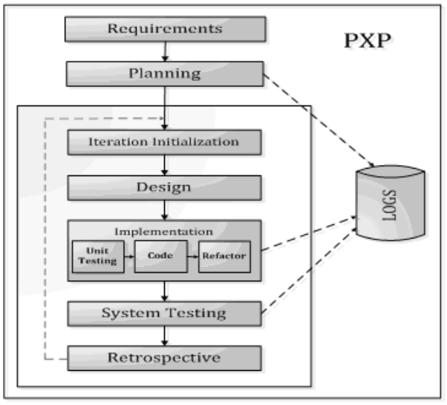
Figure 10: PXP Process Phases

Following the PXP process, the project started with the requirements phase. During this phase, both the functional and non-functional requirements were discussed with the different stakeholders. Functional requirements, such as remote meter reading, as well as non-functional requirements, such as mobile application performance, were documented. This then led to the planning phase, where various hardware and software required for the project were identified and made available. Furthermore, a project schedule was developed at this stage, taking into account the output from the requirements phase. The project schedule consisted of several tasks with their associated timelines. The design phase marked the beginning of the iteration process. During this stage, all the designs and interfaces of the mobile application were determined using both the functional and non-functional requirements. The project used
UML (Unified Modelling Language) diagrams to model workflows and business processes of the application. The production of a prototype mobile application was executed in the implementation phase. This was executed following the output from the design phase and in iterations, one feature at a time. Unit testing was then performed on each implemented feature to ensure that the feature ran as expected. As soon as all the features were developed, complete system testing was initiated. This was to ensure that the mobile application was secure, bug-free, and performed as intended. The results from the system testing were passed onto the retrospective phase, where an analysis of what can be improved in the next iteration was performed.

Summary
An investigation into how mobile applications and smart energy meters operate, along with the features required to secure them, was conducted in the literature review section. This allowed us to choose a design-based research paradigm as it aligns with research methods from the fields where products are designed for specific purposes. A research design for the secure mobile application was then developed. The design considered how data was to be collected and analysed, as well as the participants. Lastly, the nature of the project allowed us to adopt Agile PXP as the preferred project management model. Semi-structured interviews with key stakeholders were conducted to gain an accurate and deep understanding of how they feel about the mobile application.

Table 9: Research Methodology Summary
Research Objectives | Research Questions | Methods /Tools | Data Analysis | Expected Deliverables
Identify the existing threats to mobile applications and IoT technologies for smart prepaid energy meters. | What are the existing threats to mobile applications and IoT technologies for smart prepaid energy meters? | Methods: Qualitative  Tools: Literature Review | Thematic Analysis: Identifies, analyzes, and reports patterns within data. | Mobile applications and IoT technologies for smart prepaid energy meters vulnerabilities.
Assess the features needed to design a secure mobile application for smart prepaid energy meters. | What are the features needed to design a secure mobile application for smart prepaid energy meters? | Methods: Qualitative  Tools: Literature Review | Thematic Analysis: Identifies, analyzes, and reports patterns within data. | Mobile applications and IoT technologies for smart prepaid energy meters' security features.
Design a secure mobile application for smart prepaid energy meters. | How can we design a secure mobile application for smart prepaid energy meters? | Methods: Qualitative  Tools: Literature Review and Design-Based Research | Content Analysis: Systematically categorizes data | Prototype mobile application.
Evaluate the security of the designed mobile application for smart prepaid energy meters against identified existing threats. | What is the security level of the designed mobile application for smart prepaid energy meters against identified existing threats? | Methods: Qualitative  Tools: Design-Based Research and semi-structured interviews | Grounded Theory Analysis: Using interviews and observations as primary data sources.  And  Content Analysis: Systematically categorizes data | Prototype mobile application test results.

System Design

Overview
In this chapter, we defined and documented the requirements of the prototype mobile application for smart prepaid meters. The chapter described the specifications and features of the mobile application and served as a guideline for the development phase. The specifications and features are essential for the testing phase to ensure that the application is fit for purpose and fit for use. One of the main objectives of this project was to design a secure mobile application for smart energy meters. To achieve this, the mobile application requirements were divided into two categories, namely Functional requirements and Non-Functional requirements. These requirements were transformed into a structured design using UML diagrams. Data from the Functional requirements and Non-Functional requirements was transformed into a structured design using UML diagrams to model workflows and business processes.

Functional Requirements
Functional requirements are product features or functions that developers must implement to enable users to accomplish their tasks. Requirements such as transaction handling, password complexity, user interface, authentication, data processing, and transaction handling. Below is a list of the functional requirements of the secure mobile application for smart prepaid meters.

- The application should allow users (customers) to register, thus creating their accounts.
- The application should be able to verify if the details (username, email) provided by the user during registration are correct.
- The application should only accept user passwords that meet the length, complexity, and history requirements.
- The application data must be encrypted.
- The application should provide the users with the ability to add or remove their smart meters by registering and unregistering the devices.
- The application should provide the users with the ability to contact support via incident logging.
- The application should provide the users with the ability to set notifications and alarms.
- The application should provide the users with the ability to display electricity units in real-time.
- The application should provide the users with the ability to update their electricity units by sending the token remotely.
- The application should validate user identity using Multifactor Authentication services.
- The application should automatically sign out idle users.
- The application should provide the administrator with the ability to approve or reject users’ registration, reset users’ passwords, disable inactive accounts, remove meters, manage incidents, and delete accounts.

Non-Functional Requirements
Non-functional requirements (NFR) are the criteria or parameters, such as accessibility, adaptability, availability, compliance, integrity, data retention, deployment, efficiency, privacy, reporting, monitoring, security, scalability, and usability (Gedam, 2023). These are quality attributes that specify criteria that can be used to judge the operation of a system. An NFR, such as reliability, ensures that users continue to use the mobile application and are likely to recommend it to others. Unlike Functional Requirements, NFRs are difficult to test, they are evaluated subjectively. The following NFR’s requirements were considered for the prototype mobile application.

- Availability: The application should always be available (100% uptime).
- Performance: The application screens should load within 3 seconds and support up to 100 concurrent users.
- Adaptability: Agile project management was adopted for this study; the application should adjust to the changing requirements during the iteration process, as well as for future work.
- Security: The application should protect against unauthorized access and data breaches. Security is a big part of this study; therefore, authentication, authorization, encryption, and logging should be considered.
- Scalability: The application should be able to handle increasing demands without compromising performance.
- Usability: The application should be simple and easy to use.
- Reliability: The application should be free from bugs and errors.
- The Android platform was the adopted platform for this study.

Use Case Diagram
We expressed the functional requirements as a use case diagram. A use case diagram is a high-level description of how the users interact with the system. It specifies the expected behaviour of the system and helps to capture the requirements of the system. Figure 15 shows the Use Case Diagram for the prototype mobile application.

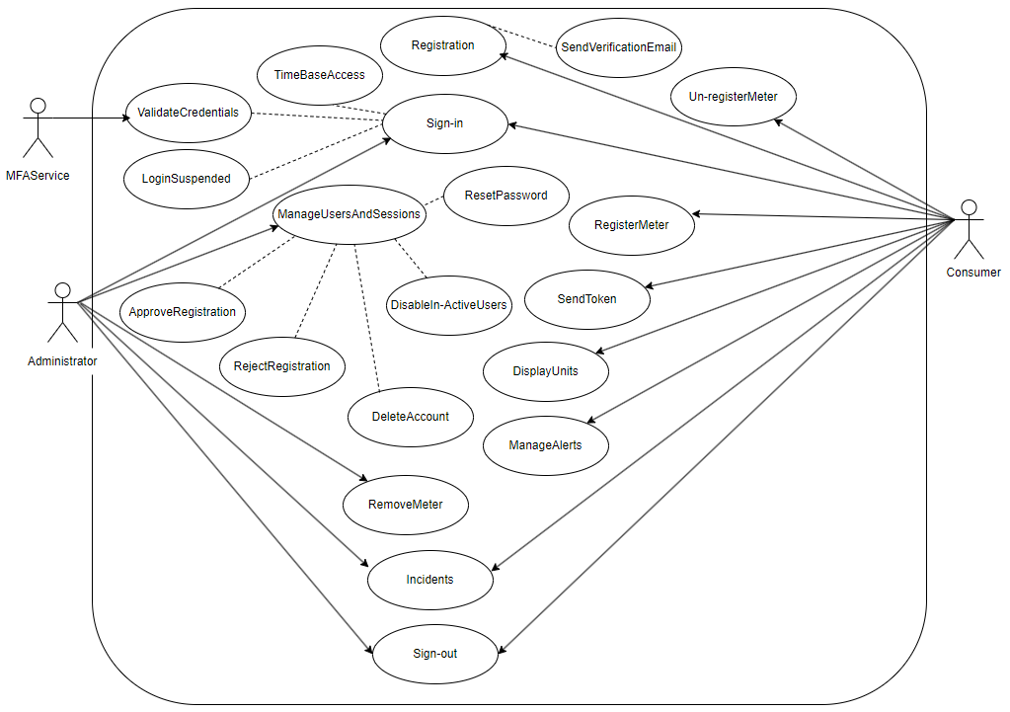
Figure 11: Use Case Diagram – Secure Mobile Application for Smart Prepaid Meters

The mobile application users (customers and administrators) are denoted as actors. Actors are external entities that interact with the system, while a use case represents a function that the system can perform. Table 8 describes the relationship between the actors and the use cases in the secure mobile for smart prepaid energy meters.

Table 10: Use Case Description
Actor | Use case | Role
Customer | Registration | Can register an account with an email and a password. These data will be stored in the database and retrieved in the future.
 | Register Meter | Can register the smart meter. Once authorized by the administrator, the meter will be added to the customer’s profile.
 | Edit Details | Can amend profile information.
 | Send Token | Can send the token numbers to the smart meter
 | Deregister Meter | Can unregister the smart meter. Once authorized by the administrator, the meter will be removed from the customer’s profile.
Administrator | Authorization | Can authorised customer and smart meter registration. The system will send an email upon successful registration.
 | Delete Account | Can delete the customer account. The system will send an email upon successful deletion.
 | Manage Users | Can reset the customer's password. The system will send an email upon successful reset.
Customer and Administrator | Sign-in | Can log in using a unique ID (email) and password, which will then be validated by the application. If the unique ID and password match the database, the system will then send an MFA token to the user. After successfully entering the token, the system will show their profile.
 | Incidents | Customers can log in and view incidents, while administrators can update incidents and close them.
 | Sign-out | Can sign out of their account after which the system shall show the landing page.

Activity Diagram
An activity diagram was used to illustrate the flow of activities through a system. Activity diagrams are UML diagrams that are used in the system workflows. Figure 18 shows the Activity diagram for the secure mobile application.

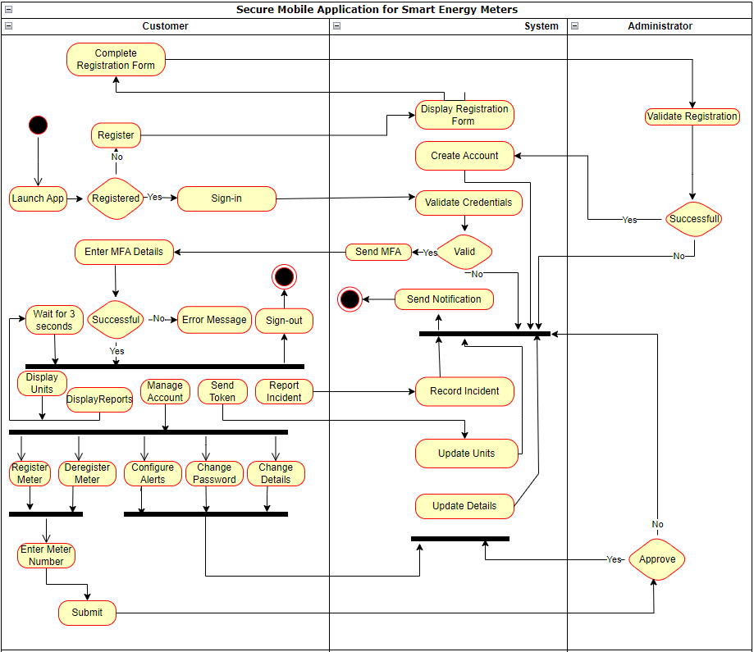
Figure 12: Activity Diagram - Secure Mobile Application for Smart Prepaid Meters

System Architecture
The system architecture provides a visual illustration of the system’s various components and how they communicate and interact with each other. To ensure confidentiality, integrity, and availability, it was important to consider the system holistically (end-to-end, from the fielded devices to the servers, to the end-user on the mobile application. This approach ensures that the data remains inaccessible to unauthorised individuals throughout the entire system.

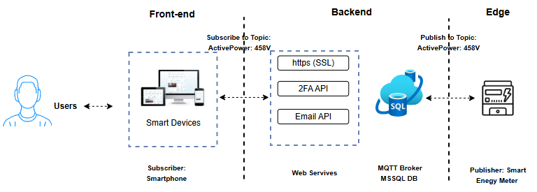
Figure 13: System Architecture – Prototype Mobile Application for Smart Prepaid Meters

Figure 13 displays the system architecture for the prototype mobile application for smart energy meters. The components are explained in detail below.
- Smart Energy Meter: NamPower’s Landis+Gyr smart energy meters.
- APN (Access Point Network): Connects the smart meter to the corporate network via mobile data.
- Internal Firewall: Protects the smart meters from attacks that have already entered the network.
- SCADA system: Used for controlling, monitoring, and analysing energy meters within the
- MV90 xi: is the MDMS (Meter Data Management System) that imports, verifies, edits, and processes energy meter data before making it available for billing.
- Backend (SAP HANA): NamPower’s database that stores data imported from the MV90 system.

Summary
Functional requirements are mandatory for every mobile application, and without them, it would be unclear what a system should do. Twelve (12) Functional requirements and eight (8) Non-Functional requirements were identified for the secure mobile application. These requirements were translated into comprehensive and detailed Use Cases and Activity Diagrams to effectively illustrate the design and behaviour of the mobile application. Draw.io to create a system architecture diagram that defines how various components, subsystems, and modules within a system interact with each other. The deliverables (system design documents) were used to design and test the prototype mobile application.

Implementation and Testing

Overview
During the Implementation phase, a prototype mobile application for smart prepaid energy meters was developed using information gathered from the design phase. The phase started with the preparation of the SAP HANA database (creating tables and stored procedures). This led to the sketching of the mobile application user interface. A prototype mobile application was then developed using the Android Studio. The chapter concluded by highlighting the challenges experienced during the implementation phase.

Smart Energy Meter
NamPower uses Landis+Gyr smart energy meters. However, due to the vendor-lock constraint, we used the IAMMETER WEM3080-150A energy meter for the prototype, Figure 13. The IAMMETER WEM3080-150A energy meter was chosen for its ability to integrate with third-party servers such as PVoutput, and HomeAssistant (TCP/SSL interface). The meter could also integrate private servers. Below are the key features of the IAMMETER WEM3080-150A energy meter.

- Real-time energy monitoring via your Wi-Fi network.
- Simply one-key Wi-Fi setup to connect to your Wi-Fi network.
- Enterprise-class performance, suitable for domestic, commercial, and industrial use, and solar systems.
- Cloud service and Mobile app are available.
- Support local monitoring via LAN or uploading the data to your specified server
- 2-pole DIN-rail mounting fits neatly in the meter box.

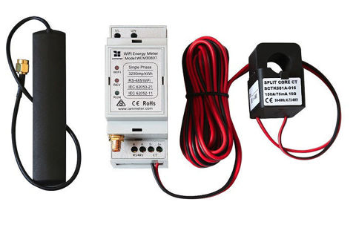
Figure 15: IAMMETER WEM3080-150A from https://store.iammeter.com/wem3080-150a

The IAMMETER WEM3080-150A energy meter was installed by certified electricians at the researchers' residences located in Wanaheda, Windhoek. The meter was connected to Home Wi-Fi (MTC Spectra 25Mbps) using a username and password as shown in Figure 15.

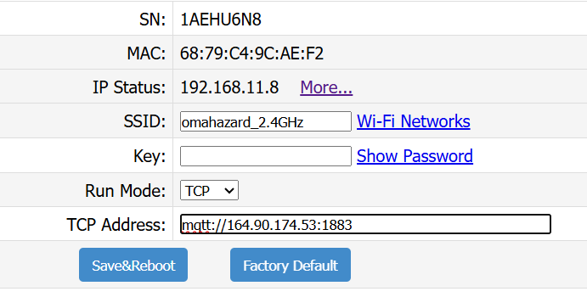
Figure 16: IAMMETER Wi-Fi settings

Server
A droplet was created from DigitalOcean to host the prototype backend services. Droplets are Linux-based virtual machines that function as scalable virtual private servers in the cloud, allowing users to run application services, databases, and supporting middleware. For this study, an Ubuntu Linux 24.04 LTS x64 droplet was created with the filesystem specification shown in Figure 17.

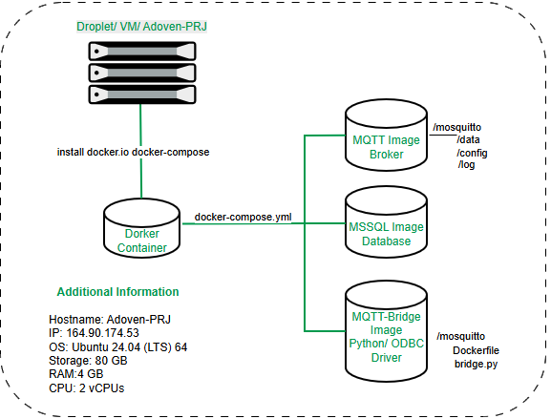
Figure 17: Ubuntu Linux Server

After the droplet was created, Docker was installed to package and run the backend services in a consistent environment. A Docker container is a lightweight and executable software package that includes the application code, runtime, system tools, libraries, and configuration required for the service to run. Containerising the MQTT broker and related services reduced deployment complexity and made it easier to restart or move the prototype environment if required. The Docker container was installed using the following steps.
      - Logged onto the Droplet via SSH and refreshed the local database of available software packages on Ubuntu.

#sudo apt update
      - We used to use the following command to install Docker packages in the Ubuntu system.

#sudo apt install docker.io docker-compose -y

      - We then configured the Docker service to automatically start whenever the system boots up and started and manually initiated the Docker background service with the following two commands.

#sudo systemctl enable docker
#sudo systemctl start docker

Eclipse Mosquitto
Eclipse Mosquitto is an open-source message broker that implements the Message Queuing Telemetry Transport (MQTT) protocol versions 5.0, 3.1.1, and 3.1. Mosquitto is lightweight and suitable for deployments that range from low-power single-board computers to full servers. The MQTT protocol provides a lightweight publish/subscribe messaging model, making it suitable for Internet of Things messaging between smart meters, backend services, and mobile applications. In the prototype, Mosquitto received meter readings from the IAMMETER device and made them available to the backend bridge for processing and storage. The following steps were used to deploy Mosquitto on the droplet using a docker-compose.yml file.
      - Logged onto the Droplet via SSH and created a mosquito directory with the necessary subdirectories for configuration, data, and logs

#mkdir -p /mosquitto/{config,data,log}
      - Created the configuration file to enable the listener and point to the password file. Password complexity was also enabled on the Linux server with the following parameters, as recommended by NIST Appendix X (Dibley, 2024).

root@Adoven-PRJ:~# more /mosquitto/config/mosquitto.conf
listener 1883 0.0.0.0
persistence true
persistence_location /mosquitto/data/
log_dest file /mosquitto/log/mosquitto.log
## Authentication
allow_anonymous false
password_file /mosquito/config/passwd

      - Created the docker-compose.yml file to define the services and mount the local directories.

root@Adoven-PRJ:/mosquitto# more docker-compose.yml
version: '3.8'

services:
mqtt:
image: eclipse-mosquitto:latest
container_name: mqtt
ports:
- "1883:1883"
- "9001:9001"
volumes:
- /mosquitto/config:/mosquitto/config
- /mosquitto/data:/mosquitto/data
- /mosquitto/log:/mosquitto/log
restart: always

      - Created the user account and the password file.

root@Adoven-PRJ:/mosquitto#docker exec -it mosquitto mosquitto_passwd -b /mosquitto/config/passwd adoven @EdenEmily2026

      - Started the eclipse-mosquitto Docker image container.

root@Adoven-PRJ:/mosquitto# docker-compose up -d
root@Adoven-PRJ:/mosquitto# docker-compose ps

Name Command State Ports
-----------------------------------------------------------------------------------------------------------------------------------
mqtt /docker-entrypoint.sh /usr ... Up 0.0.0.0:1883->1883/tcp,:::1883->1883/tcp, 0.0.0.0:9001->9001/tcp,:::9001->9001/tcp

MSSQL Database
The project used Microsoft SQL Server (often abbreviated as MSSQL) database to collect, store, and analyze IoT data. Microsoft SQL Server is a relational database management system (RDBMS) developed by Microsoft. The docker-compose.yml file was modified to define the mssql database version 2022 image before following the following steps.
      - Logged onto the Droplet via SSH and created a mosquito directory with the necessary subdirectories for configuration, data, and logs

root@Adoven-PRJ:/mosquitto# vi docker-compose.yml

version: '3.8'

mssql:
image: mcr.microsoft.com/mssql/server:2022-latest
container_name: mssql
environment:
ACCEPT_EULA: "Y"
MSSQL_SA_PASSWORD: "@EdenEmily2026"
ports:
- "1433:1433"
volumes:
- mssqldata:/var/opt/mssql
restart: always

volumes:
mssqldata:

      - Started the mssql image container.

root@Adoven-PRJ:/mosquitto# docker-compose up -d
root@Adoven-PRJ:/mosquitto# docker-compose ps

Name Command State Ports
---------------------------------------------------------------------------------------------------------------------------------
mssql /opt/mssql/bin/launch_sqls ... Up 0.0.0.0:1433->1433/tcp,:::1433->1433/tcp

Backup encryption protects the contents of the data backup, log backups, and delta or differential backups including snapshots. Data and log volume encryption protect the data and log area located at /hana/data/NPM and /hana/log/NPM respectively.

In addition to enabling encryption, the system account login was deactivated as recommended by SAP. Just like the root account on the operating system level, the system account has unlimited access to the SAP database and hackers can attempt to guess the password. Password complexity was also enabled on the SAP HANA database with the following parameters as recommended by NIST Appendix X (Dibley, 2024).

Database
Microsoft SQL Server was utilised for the prototype mobile application. The database and its associated tables were defined at the outset to ensure the development of a reliable, scalable, and high-performance solution. Tables 11 and 12 present the definitions for the EnergyData and CustomerData tables, respectively, outlining the data types and constraints.
Establishing these definitions early provides a structured schema that supports data integrity, optimises storage, and facilitates efficient long-term maintenance.
Table 11: Table EnergyData
Field name | Data type | Description
ReadingID | INT PRIMARY KEY | Auto-incrementing ID for each record
DeviceSN | VARCHAR(20) | The device's Serial Number.
Voltage | FLOAT | voltage (from Data[0]).
Current | FLOAT | Line current (from Data[1]).
ActivePower | FLOAT | Real-time power in Watts (from Data[2]).
ImportEnergy | FLOAT | Total kWh consumed (from Data[3]).
ExportEnergy | FLOAT | Total kWh exported (from Data[4]).
Timestamp | DATETIME | The time the record was added (crucial for time-series data).

Table 12: Table CustomerData
Field name | Data type | Description
ReadingID | INT PRIMARY KEY | Auto-incrementing ID for each record
DeviceSN | VARCHAR(20) | The device's Serial Number.
Voltage | FLOAT | voltage (from Data[0]).
Current | FLOAT | Line current (from Data[1]).
ActivePower | FLOAT | Real-time power in Watts (from Data[2]).
ImportEnergy | FLOAT | Total kWh consumed (from Data[3]).
ExportEnergy | FLOAT | Total kWh exported (from Data[4]).
Timestamp | DATETIME | The time the record was added (crucial for time-series data).

The AdovenDB and its associated tables were created using the following steps.
      - Logged into the Droplet via SSH and executed the command below to create the AdovenDB:

#docker exec -it mssql /opt/mssql-tools18/bin/sqlcmd \
> -S localhost -U sa -P "@EdenEmily2026" -C
> -Q "CREATE DATABASE AdovenDB;"

      - Executed the following command to confirm if the AdovenDB database was created.

#docker exec -it mssql /opt/mssql-tools18/bin/sqlcmd -S localhost -U sa -P "@EdenEmily2026" -C -d master -Q "SELECT name FROM sys.databases"
name
---------------------------------------------------------------------------------------------------------------------------
master
tempdb
model
msdb
AdovenDB

      - Executed the command below to create the EnergyData table:

#docker exec -it mssql /opt/mssql-tools18/bin/sqlcmd \
> -S localhost -U sa -P "@EdenEmily2026" -C
> -Q 'CREATE TABLE EnergyData (ReadingID INT IDENTITY(1,1) PRIMARY KEY, DeviceSN VARCHAR(20), Voltage FLOAT, [Current] FLOAT, ActivePower FLOAT, ImportEnergy FLOAT, ExportEnergy FLOAT, Timestamp DATETIME DEFAULT GETDATE());'

Conceptual Data Model
The conceptual data model describes the database at a very high level and represents the overall structure of data required to support the business requirements, independent of any software or data storage structure. It represents the main concepts in your database and the relationships between them. The three main components of the conceptual data model are entities, attributes, and relationships. A conceptual data model can help developers identify potential problems or inconsistencies in their design. Draw.io was used to illustrate the conceptual data model for the secure mobile application.
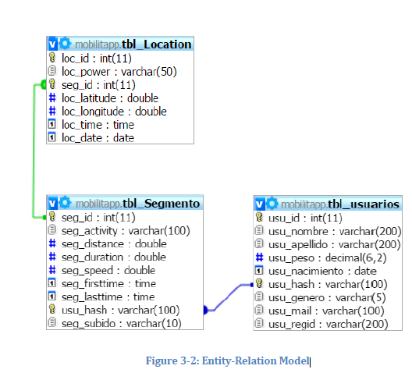

Stored Procedures
layout editor, code templates for common app features, and lint tools to catch performance, usability, and version compatibility.

Python
We used a Python Snippet to bridge the IAMMETER WEM3080 data from an MQTT broker to an MS SQL database. The script used the paho-mqtt library to subscribe to the broker and pyodbc to insert the parsed JSON data into the SQL tables.

The AdovenDB and its associated tables were created using the following steps.
      - Logged into the Droplet via SSH and executed the command to create a Python script called bridge.py in the /mosquito directory.

root@Adoven-PRJ:/mosquitto# vi bridge.py

      - We then installed the Python packages required for the script:

root@Adoven-PRJ:/mosquitto# pip3 install paho-mqtt pyodbc --break-system-packages

      - Ran the bridge inside a Docker container by creating a file called Dockerfile with the following content.

root@Adoven-PRJ:/mosquitto# vi Dockerfile
FROM python:3.11-slim

RUN apt-get update && apt-get install -y curl gnupg2

RUN curl -fsSL https://packages.microsoft.com/keys/microsoft.asc | gpg --dearmor -o /usr/share/keyrings/microsoft-prod.gpg \
&& echo "deb [arch=amd64,arm64,armbf signed-by=/usr/share/keyrings/microsoft-prod.gpg] https://packages.microsoft.com/debian/12/prod bookworm main" > /etc/apt/s
ources.list.d/mssql-release.list

RUN apt-get update && ACCEPT_EULA=Y apt-get install -y msodbcsql17 unixodbc-dev

RUN pip install paho-mqtt pyodbc

COPY bridge.py /app/bridge.py
WORKDIR /app
CMD ["python", "bridge.py"]

      - We then modified the docker-compose.yml by adding the bridge service to the bottom of the file

root@Adoven-PRJ:/mosquitto# vi docker-compose.yml

mqtt-bridge:
build: .
container_name: mqtt-bridge
depends_on:
- mqtt
- mssql
restart: always

      - Ran the command below to build and start the mqtt-bridge image

root@Adoven-PRJ:/mosquitto# docker-compose up -d –build
root@Adoven-PRJ:/mosquitto# docker-compose up -d
mssql is up-to-date
mqtt is up-to-date
Creating mqtt-bridge ... done
root@Adoven-PRJ:/mosquitto#

      - Ran the command below to check the mqtt-bridge logs, and it confirmed that the data was being successfully saved from the smart meter.

root@Adoven-PRJ:/mosquitto# docker logs -f mqtt-bridge
Script starting...
/app/bridge.py:46: DeprecationWarning: Callback API version 1 is deprecated, update to latest version
client = mqtt.Client()
Attempting to connect to broker: mqtt
Starting loop...
Connected to MQTT Broker with result code 0
Subscribed to topic: device/+/realtime
New message received on device/1AEHU6N8/realtime
Successfully saved data for 1AEHU6N8: 611.0W
New message received on device/1AEHU6N8/realtime
Successfully saved data for 1AEHU6N8: 611.0W
New message received on device/1AEHU6N8/realtime
Successfully saved data for 1AEHU6N8: 610.0W image

root@Adoven-PRJ:/mosquitto# docker-compose up -d --build

      - Ran the SQL statement below to select the top 10 data from the AdovenDB.

root@Adoven-PRJ:/mosquitto# docker exec -it mssql /opt/mssql-tools18/bin/sqlcmd \
-S localhost -U sa -P "@EdenEmily2026" -C \
-Q "SELECT TOP 10 [DeviceSN], [Voltage], [Current], [ActivePower], [Timestamp] FROM AdovenDB.dbo.EnergyData ORDER BY [Timestamp] DESC;"
DeviceSN Voltage Current ActivePower Timestamp
-------------------- ------------------------ ------------------------ ------------------------ -----------------------
1AEHU6N8 233.56 3.2000000000000002 599.0 2026-04-28 20:53:04.237
1AEHU6N8 233.41999999999999 3.1800000000000002 598.0 2026-04-28 20:52:04.700
1AEHU6N8 233.41999999999999 3.23 609.0 2026-04-28 20:51:05.350
1AEHU6N8 233.24000000000001 3.1899999999999999 600.0 2026-04-28 20:50:05.533
1AEHU6N8 233.84999999999999 3.2400000000000002 612.0 2026-04-28 20:49:05.977
1AEHU6N8 234.21000000000001 2.77 540.0 2026-04-28 20:48:06.390
1AEHU6N8 233.99000000000001 3.0800000000000001 623.0 2026-04-28 20:47:06.817
1AEHU6N8 234.06 3.02 610.0 2026-04-28 20:46:07.437
1AEHU6N8 234.53999999999999 3.0 611.0 2026-04-28 20:45:07.717
1AEHU6N8 234.40000000000001 3.0 611.0 2026-04-28 20:44:08.180

(10 rows affected)
root@Adoven-PRJ:/mosquitto#

The MQTT bridge logs confirm that the IAMMETER WEM3080 device is successfully publishing data over Wi-Fi using the MQTT protocol to the Mosquitto broker. The broker is effectively managing the traffic, while the Python bridge application is reliably parsing the JSON payloads and inserting the data into the Microsoft SQL Server (MSSQL) database at one-minute intervals. This end-to-end data flow demonstrates stable communication between the device, messaging infrastructure, and database layer, indicating that the integration is functioning as intended.

User Interface
A UI (User Interface) is a graphical display on a mobile device that allows the user to interact with the device's apps, features, content, and functions. A well-designed user interface ensures that users can easily navigate the mobile application and complete common tasks without assistance. For this study, information from the requirements analysis, use case diagram, and activity diagram was used to sketch the mobile application wireframes.
The wireframes in Figure 18 show the main user-facing screens of the prototype. The login screen allows registered users to access the application using an email address and password, with options for password recovery and new account registration. This screen supports the access-control requirement by limiting meter-related functions to authenticated users.
The registration screen captures the user's name, surname, email address, physical address, smart meter number, password, and password confirmation. Capturing the smart meter number during registration links the customer account to a specific meter and supports administrator approval before the meter is activated on the user's profile.
The dashboard screen provides the core mobile app functions. It displays the available electricity units, provides a field for entering a prepaid token, and includes controls for submitting the token, viewing reports, managing the account, logging incidents, and signing out. The dashboard was designed to keep the most important meter information visible while keeping secondary functions accessible through clear buttons.

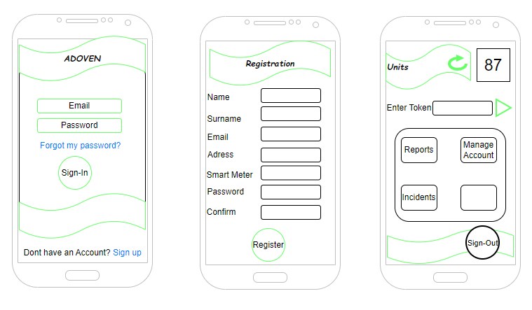
Figure 18: Mobile Application Wireframes

Draw.io was used to sketch the low-fidelity wireframes for the secure mobile application, as shown in Figure 18. The sketches were first drafted on paper to allow rapid iteration before the final concept was adopted. This process helped align the interface with the functional requirements, especially registration, authentication, meter viewing, token submission, account management, incident logging, and sign-out.
The wireframes were later used as a guide during prototype development. They provided a simple visual reference for screen layout, navigation flow, and the placement of user controls. The design intentionally remained simple because the target users need to quickly check available units, submit meter-related information, and receive feedback from the application.

Visual Studio Code
Visual Studio Code was used as the main development environment for the prototype mobile application and supporting backend scripts. The mobile application was developed with the Flutter SDK and the Dart programming language, while Python was used for the MQTT-to-database bridge. Visual Studio Code extensions for Flutter, Dart, and Python assisted with source-code editing, debugging, and project navigation. The Android Emulator was used to run and debug the application on a virtual Android device before testing on the target Android platform.

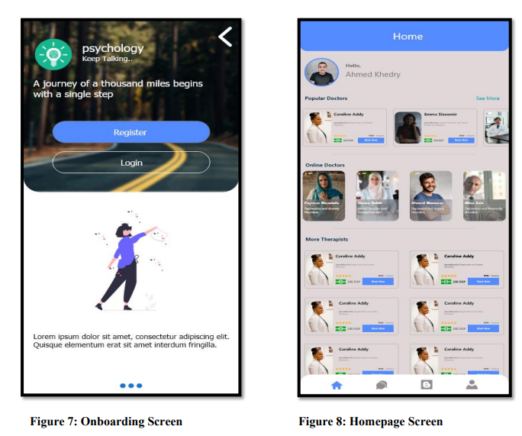

Application Programming Interface (API)
APIs are the key communication channels between the mobile application and the back-end system (database). APIs handle sensitive data and thus need to be properly secured. The following APIs were used during the development of the prototype.

Two-Factor Authentication API
The two-factor authentication API was included to strengthen the sign-in process. After a user submits a valid email address and password, the application requests a one-time verification code from the authentication service. The user must enter this code before access to the dashboard is granted.
This additional verification step reduces the risk of unauthorised access if a password is guessed, reused, or compromised. It also supports the security requirements of the study by combining something the user knows, namely the password, with a temporary verification code delivered through a separate communication channel. For the prototype, the API interaction was designed to validate the code before exposing meter readings, token submission, reports, account management, or incident functions.

Email Verification API
The email verification API was used to confirm that the email address supplied during registration belongs to the user. When a new account is created, the system sends a verification message to the registered email address. The account is only treated as valid after the user completes the verification process.
Email verification improves data quality by reducing incorrect or fake account details and supports secure account recovery. It also gives the system a trusted communication channel for registration approval, password reset notifications, incident updates, and account-management messages. In the prototype workflow, email verification formed part of the registration process before the user could access meter-specific functions.
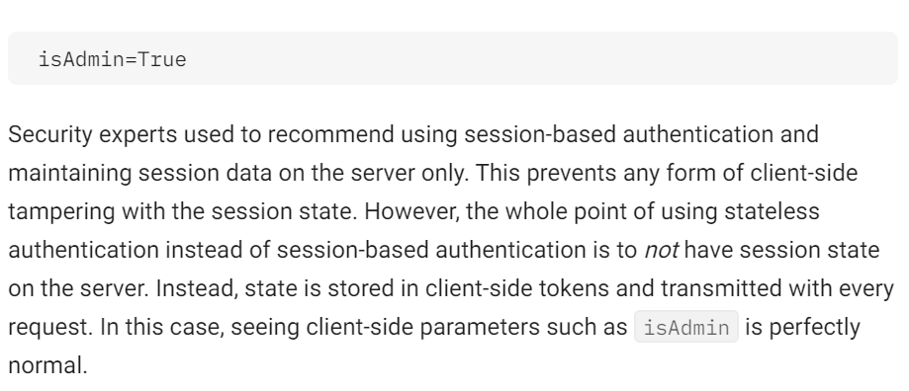

Testing
The testing phase comprised a group of activities that examined the prototype mobile application. This phase was important to verify that the mobile application meets all the requirements and functions according to design parameters. Functional/Unit testing, security testing, and performance testing were conducted to ensure that the mobile application operated without errors and met the security standards expected from this research. The mobile application quality and security standards were tested based on the guidelines provided by the Android developer website. Volunteers were identified to perform the acceptance testing; this was to confirm that the mobile application satisfies the end users. The test results were also evaluated in this chapter.

Unit Testing
Mobile application unit testing involves validating individual, isolated components of the application, such as functions or classes, to ensure they operate correctly. The prototype mobile application was tested against authentication, registration, and navigation scenarios, as outlined in Table 13.

Table 13: Unit Testing
Actor | Event |  | Values |  | Expected Results |  | Results
Authentication | Click on Login and submit the correct username and password |  | Email: sadoven@gmail.com  Password: $tr0ngPa$$26 |  | Login successful |  | Pass
 | Click on Login and submit the wrong username, but the correct password |  | Email: sxxxadoven@gmail.com  Password: $tr0ngPa$$26 |  | Login unsuccessful |  | Pass
 | Click on Login and submit the correct username, but the wrong password |  | Email: sadoven@gmail.com  Password: WrongPa$$26 |  | Login unsuccessful |  | Pass
Registration | Provide a valid email, a valid (Strong) password, and a username |  | Email: valid@gmail.com  Password: $tr0ngPa$$26  Username: Adoven |  | Registration successful |  | Pass
 | Provide an invalid email, a valid (Strong) password, and a username |  | Email: invalidgmail.com  Password: $tr0ngPa$$26  Username: Adoven |  | Registration unsuccessful |  | Pass
 | Provide a valid email, an invalid (weak) password, and a username |  | Email: valid@gmail.com  Password: password123  Username: Adoven |  | Registration unsuccessful |  | Pass
Page Navigation Links | "Analytics" Button |  | Clicking a link or button trigger |  | User moved to the dashboard page to view the meter readings |  | Pass
 | "Add Meter" Button |  | Clicking a link or button triggers |  | User moved to the meter addition form/page. |  | Pass
 | "Sign Out" Button |  | Clicking a link or button triggers |  | User returned to the landing page. |  | Pass

Security Testing
Mobile application security testing (MAST) assesses risks and vulnerabilities that may exist in mobile applications by simulating real-world attacks through both automated and manual methods. The prototype was assessed against the OWASP Mobile Application Security Verification Standard (MASVS), with particular attention to authentication, session management, data storage, network communication, input validation, and error handling.
The security testing checked whether sensitive data was protected, whether invalid login attempts were rejected, whether weak passwords were blocked, whether unauthorised users could bypass authentication, and whether application traffic and backend access were restricted to the intended services. The testing also considered the IoT context of the application, since a compromise of the mobile interface could expose meter data or allow unauthorised meter-related actions.

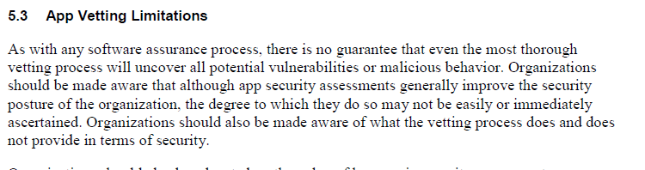

Penetration Testing
Penetration testing was performed to identify weaknesses that could be exploited through the mobile application or its backend services. The test scenarios included incorrect login attempts, weak password submission, unauthorised dashboard access, invalid token submission, and attempts to reach backend services without a valid session. The expected result was that the application would reject invalid input, prevent access to protected functions, and avoid exposing sensitive error messages.

Secure Code Testing

Secure code testing was conducted by reviewing the mobile application and backend scripts for insecure coding practices. The review focused on hard-coded credentials, input validation, error handling, authentication checks, password handling, API calls, and database interaction. The purpose was to ensure that the implementation followed the security requirements identified in the literature review and requirements analysis.

Performance Testing
Mobile application performance testing was conducted to evaluate whether the prototype remained stable, responsive, and usable during normal operations. The focus was on screen loading, login response, dashboard loading, retrieval of meter readings, and writing meter-related actions to the backend.
The system's performance was assessed by measuring the time required to retrieve data from the backend and the time taken to write data to the backend system. The target was for common screens and actions to complete within the performance requirement of approximately three seconds under normal test conditions.

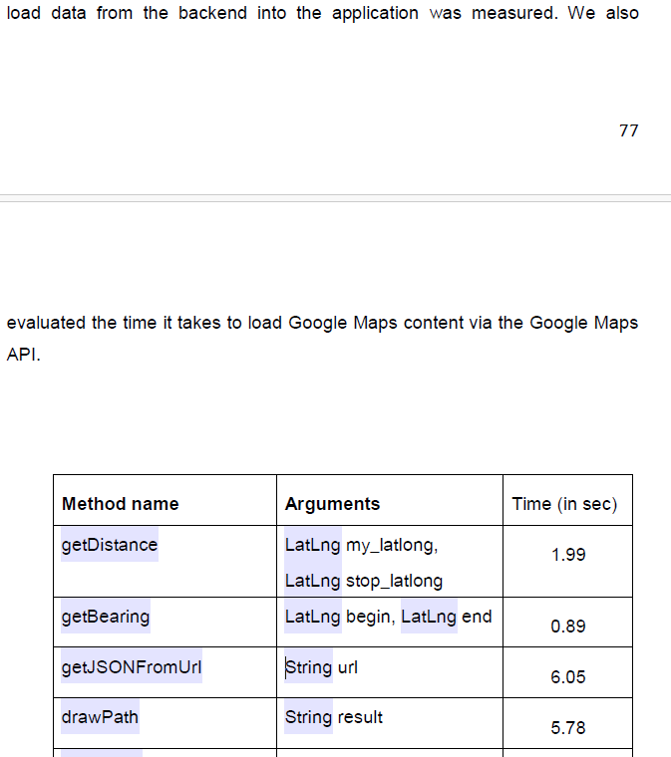
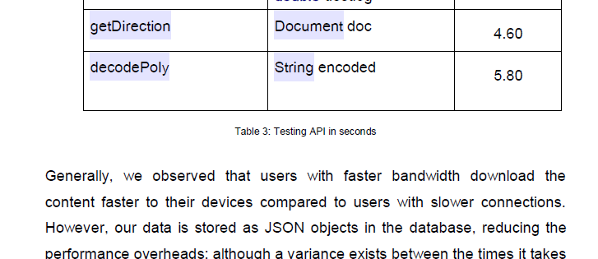

Challenges
The first challenge we faced was the fact that NamPower uses SAP Smart Prepayment solution as opposed to STS (Standard Transfer Specification) Token. SAP Smart Prepayment works like a wallet which lets you pre-load any amount of money that reflect as credit on your account. This meant that the possibility of sending a token to the meter was not feasible. The other challenge we faced was that with the SAP Smart Prepayment solution the meter reading were uploading into SAP via a flat file. This flat file was generated by the MV90 xi system that is used to read the meter data. This meant that the mobile application did not access to real time data but rather consumption information that is uploaded every 24hours. The project had to rely on the flat file that was produced by the MV90 xi system to read the meter data.

Summary
During the implementation phase, the prototype mobile application and its supporting backend services were developed from the requirements and design artefacts. The work included preparing the database, configuring the cloud server, deploying the MQTT broker, connecting the smart meter data flow, sketching the user interface, implementing the Android-facing mobile application, and defining the API interactions used for authentication and email verification. The chapter also described the functional, security, and performance tests used to evaluate whether the prototype met the study objectives.
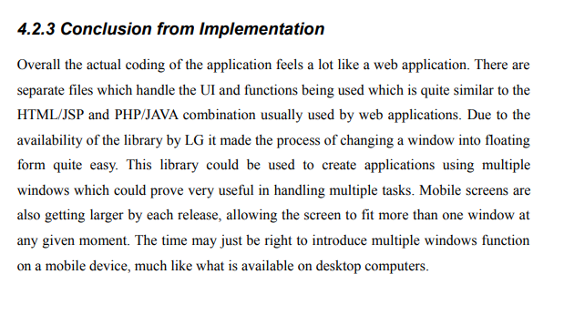

Evaluation and Results

Overview
This chapter presents and discusses the evaluation of the prototype mobile application. The evaluation considered whether the prototype met the functional, security, and performance requirements defined earlier in the study. Functional/unit testing verified the expected behaviour of registration, authentication, navigation, meter viewing, and sign-out. Security testing assessed whether the application protected user access and meter-related data. Performance testing assessed whether the application remained responsive when retrieving and writing data through the backend.

Unit Testing
The functional/unit testing results showed that the main user workflows operated as expected. Valid login credentials allowed the user to access the application, while invalid usernames, incorrect passwords, invalid email formats, and weak passwords were rejected. The registration workflow accepted valid account details and blocked invalid submissions.
Navigation testing also produced the expected results. The analytics/dashboard button opened the screen used to view meter readings, the add-meter function opened the meter registration form, and the sign-out function returned the user to the landing page. Based on the test cases recorded in Table 13, the prototype passed the selected functional tests.

Security Testing
The security testing results indicated that the prototype implemented the core controls required for a secure mobile application. The application rejected invalid login attempts, enforced stronger password requirements during registration, required account verification before access to protected functions, and separated ordinary customer functions from administrator functions. The tests also confirmed that meter-related functions were only available after successful authentication.

8.3.1 Penetration Testing
The penetration testing scenarios did not identify a successful bypass of the login process in the tested prototype workflow. Invalid credentials were rejected, protected screens were not intended to be accessible before authentication, and invalid token or form input was handled without granting access to restricted functions. However, because the prototype was developed for research purposes, further testing would be required before production deployment, including testing with a larger user base, real utility infrastructure, and hardened production APIs.

8.3.2 Secure Code Review
The secure code review confirmed that the prototype logic aligned with the study's security requirements, including authentication checks, password validation, and controlled access to meter-related features. The review also highlighted areas that should be strengthened in future work, such as centralised secrets management, production-grade certificate validation, detailed audit logging, and stronger separation between development and production configuration.

Performance Testing
The performance testing results showed that the prototype was responsive under the limited test conditions used in the study. Login, navigation, dashboard loading, and backend read/write operations completed within an acceptable time for prototype evaluation. The results suggest that the application design is suitable for the proof-of-concept stage, although production deployment would require load testing with more concurrent users, larger meter datasets, and live network conditions.

Interviews and Questionnaires
Several interviews were conducted with IT and OT professionals from five (5) different organizations within Namibia. The interviews were intended to gain a better understanding of cybersecurity maturity levels within the country and to give participants an opportunity to test the prototype mobile application for potential bugs and limitations. The participant group included 5 IT Managers, 5 Cybersecurity Administrators, 5 Developers, and 5 OT Administrators. Questionnaires were also handed out to five randomly selected customers to collect user feedback on the need for a mobile application for smart prepaid energy meters.

8.5.1 Interviews
The interviews provided qualitative feedback on the usefulness, security expectations, and practical limitations of the proposed mobile application. Participants generally agreed that a mobile application for smart prepaid energy meters could improve customer convenience by reducing the need to physically access the meter, especially when customers need to recharge electricity units remotely.
IT managers and cybersecurity administrators emphasised that the mobile application should not be treated as a standalone customer service tool only. They highlighted the need for secure authentication, user approval, audit logging, incident management, and alignment with organisational cybersecurity policies. Developers further indicated that API security, input validation, error handling, and secure storage of credentials would be important before the solution could be deployed in a production utility environment.
The customer questionnaire responses supported the need for a mobile application that can display available units, provide usage visibility, and help customers avoid unexpected electricity interruptions. The feedback therefore supported the study's argument that a secure mobile interface can improve customer experience while still requiring strong controls to protect meter data and backend systems.

To what exent to do agree or disagree

Respondents/Questions | To what extent do you agree or disagree with the following statement: Our organization have a documented and communicated cybersecurity risk management policies, processes, and controls? |  | To what extent do you agree or disagree with the following statement: Our organization cybersecurity roles and responsibilities defined in a way that ensures the organization's mission is considered when making risk-based decisions? | To what extent do you agree or disagree with the following statement: Our organization as the adopted a particular industry security standard or framework (NIST, PCI-DSS, and ISO/IEC 27001)? | To what extent do you agree or disagree with the following statement: The is a need for a mobile application for smart prepaid energy meters in Namibia
Manager 1
Manager 2

Manager 3
Manager 4
Manager 5

Firstly, 60% of the reviewers indicated that the framework will support the identification of critical information assets inventory and business functions, while 40% remained neutral. With regards to detecting cybersecurity attacks in the banking sector in a timely manner, 77% of the reviewers showed that the framework will be effective while 23% chose to remain neutral. To add to that, 67% of reviewers indicated that the framework

 | To what extent do you agree or disagree with the following statement:
Respondents/Questions | Our organization has a process in place to ensure that all newly implemented systems (applications) comply with the security standards. | Our organization has processes in place to regularly monitor and update the cybersecurity risk profiles. | Our organization has processes and procedures in place to ensure collaboration with other teams, such as developers and operations technology, to ensure overall security. | Our organization performs penetration testing and vulnerability assessments atleast once a year. | Our organization provides us with the means to stay up-to-date with the latest security threats and attack vectors
Cyber Admin 1
Cyber Admin 2
Cyber Admin 3
Cyber Admin 4
Cyber Admin 5

Firstly, 60% of the reviewers indicated that the framework will support the identification of critical information assets inventory and business functions, while 40% remained neutral. With regards to detecting cybersecurity attacks in the banking sector in a timely manner, 77% of the reviewers showed that the framework will be effective while 23% chose to remain neutral. To add to that, 67% of reviewers indicated that the framework

Thesis-AndreRibeiro Development of Mobile Applications using a Model-Driven.pdf

Summary
Secure code testing was conducted by reviewing the mobile application and backend scripts for insecure coding practices. The review focused on hard-coded credentials, input validation, error handling, authentication checks, password handling, API calls, and database interaction. The purpose was to ensure that the implementation followed the security requirements identified in the literature review and requirements analysis.

Conclusions and Future Work

Algorithms that were considered secure in the past may become insecure over time; therefore, it's important to periodically check current best practices and adjust configurations accordingly.

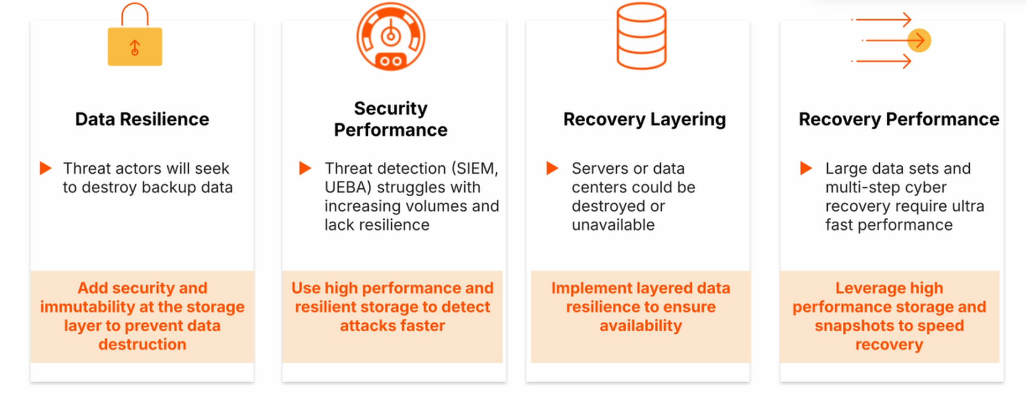
https://mobile-security.gitbook.io/mobile-security-testing-guide/general-mobile-app-testing-guide/0x04g-testing-cryptography

https://www.ncbi.nlm.nih.gov/books/NBK260175/

Previous work has mostly looked at smart energy meters security and mobile application security independently. This study focused on an end-to-end process whereby a secure mobile application was designed for smart prepaid energy meters in Namibia.

Currently, Smart Metering innovation in Namibia is around helping utility companies with their dept collection strategy and not enhance consumer experience.

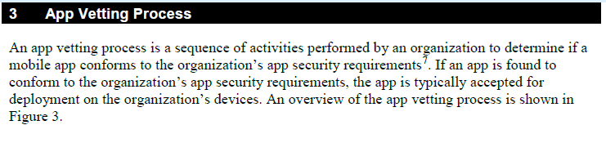
System Architecture

The system architecture provides a visual illustration of the system’s various components and how they communicate and interact with each other. To ensure confidentiality, integrity, and availability, it was important to consider the system wholistically (end-to-end, from the fielded devices to the servers, to the end-user on the mobile application. This approach ensures that the data remains inaccessible to unauthorised individuals throughout the entire system.
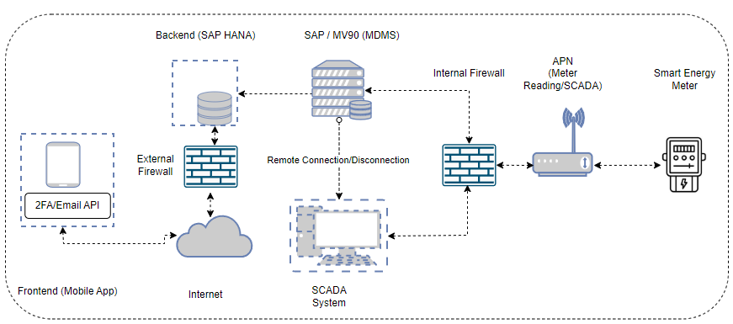
Figure 20: System Architecture - Use Case Diagram – Secure Mobile Application for Smart Prepaid Meters

Figure 19 displays the system architecture for the secure mobile application for smart energy meters. The components are explained in detail below.
- Smart Energy Meter: NamPower’s Landis+Gyr smart energy meters.
- APN (Access Point Network): Connects the smart meter to the corporate network via mobile data.
- Internal Firewall: Protects the smart meters from attacks that have already entered the network.
- SCADA system: Used for controlling, monitoring, and analysing energy meters within the company.
- MV90 xi: is the MDMS (Meter Data Management System) that imports, verifies, edits, and processes energy meter data before making it available for billing.
- SAP S/4HANA: is NamPower’s enterprise resource planning system whereby the SAP Prepayment solution is installed.
- Backend (SAP HANA): NamPower’s database that stores data imported from the MV90 system.
- External Firewall: NamPower’s firewall is deployed between the internal and external networks to prevent unauthorized access from the Internet.
- Internet: The worldwide system of interconnected computer networks.
- Frontend (2FA/Email API): This is the mobile application along with all the APIs installed.

References

Agarwal, H. (2021, April 1). Mobile App Hacking and its growing popularity. https://www.appknox.com/blog/mobile-app-hacking
Agile Project Management: A Beginner’s Guide | Adobe Workfront. (2022, March 18). Adobe. https://business.adobe.com/blog/basics/agile
Alharahsheh, H. H., & Pius, A. (2020). A Review of key paradigms: positivism VS interpretivism. Global Academic Journal of Humanities and Social Sciences, 2(3), 39–43. https://doi.org/10.36348/gajhss.2020.v02i03.001
Allemang, B., Sitter, K., & Dimitropoulos, G. (2022). Pragmatism as a paradigm for patient-oriented research. In Health Expectations (Vol. 25, Issue 1, pp. 38–47). John Wiley and Sons Inc. https://doi.org/10.1111/hex.13384
Al-Ratrout, S., Husain Tarawneh, O., HusniAltarawneh, M., & Yosef Altarawneh, M. (2019). Mobile Application Development Methodologies Adopted in Omani Market: A Comparative Study. International Journal of Software Engineering & Applications (IJSEA), 10(2). https://doi.org/10.5121/ijsea.2019.10202
Annual mobile app downloads worldwide by store 2026 | Statista. (2021, September 15). Statista. https://www.statista.com/statistics/1010716/apple-app-store-google-play-app-downloads-forecast/
Armstrong, M., Dopp, C., & Welsh, J. (2020). Design-Based Research. The Students’ Guide to Learning Design and Research. https://edtechbooks.org/studentguide/design-based_research
Asri, S. A., Made, G., Sunaya, A., Prihatini, P. M., & Setiawan, W. (2018). Comparing Traditional and Agile Software Development Approaches: Case of Personal Extreme Programming. https://www.atlantis-press.com/proceedings/icst-18/55910901
Barcia, R. (2022). Android Studio: Build apps on the official IDE for Android - IBM Garage Practices. https://www.ibm.com/garage/method/practices/code/tool_android_studio/
Campion, A. (2022, April 13). Should I get a smart meter? Pros and cons - Confused.com. https://www.confused.com/gas-electricity/guides/what-is-a-smart-meter
CENORED Annual Report 2022. (2023). https://cenored.com.na/wp-content/uploads/2022/12/Annual-Report2022.pdf
Charig, N. (2020, July 22). The smart grid – what it is, and why we need it. https://www.power-and-beyond.com/the-smart-grid-what-it-is-and-why-we-need-it-a-390575215d5f5a136fc35a372cba7b26/
CHRISTENSEN, K., & WEST, R. (n.d.). The Development of Design-Based Research – Foundations of Learning and Instructional Design Technology. Retrieved September 23, 2022, from https://lidtfoundations.pressbooks.com/chapter/design-based-research/
Collier, K. (2022, September 14). Popular school messaging app hacked to send explicit image to parents. https://www.nbcnews.com/tech/security/popular-school-messaging-app-hacked-send-explicit-image-parents-rcna47687
Data Collection: Best Methods + Practical Examples | Iterators. (2021, August 4). ITERATORS. https://www.iteratorshq.com/blog/data-collection-best-methods-practical-examples/
De Craemer, K., & Deconinck, G. (n.d.). Analysis of State-of-the-art Smart Metering Communication Standards.
Developers. (2024, May 30). Security guidelines | App quality | Android Developers. https://developer.android.com/privacy-and-security/security-tips
Dibley, J. (2024). NIST Password Guidelines: What You Need to Know. Https://Blog.Netwrix.Com/. https://blog.netwrix.com/nist-password-guidelines
Dzhurov, Y., & Krasteva, I. (2009). Personal Extreme Programming – An Agile Process for Autonomous Developers. https://core.ac.uk/outputs/213561553/?utm_source=pdf&utm_medium=banner&utm_campaign=pdf-decoration-v1
Erongo RED Annual Report 2021-2022. (2023). https://www.erongored.com/wp-content/uploads/2024/06/Erongo-RED-Annual-Report-2021-2022-2024.pdf
Garcia, D. (2021a, September 22). How do smart meters communicate? | EMnify Blog. https://www.emnify.com/blog/how-smart-meters-communicate
Garcia, D. (2021b, September 22). How do smart meters communicate? | EMnify Blog. https://www.emnify.com/blog/how-smart-meters-communicate
Gedam, A. (2023, June 28). 12 Key NFR Considerations for Mobile Application Development. https://www.globallogic.com/insights/blogs/nonfunctional-requirements-nfr-mobile-app-development/
Gorodyansky, D. (2017, May 9). 3 Reasons Why Privacy Matters to Your Business, Your Brand and Your Future. https://www.entrepreneur.com/science-technology/3-reasons-why-privacy-matters-to-your-business-your-brand/293785
Graves, E. (2016, November 22). Agile Principle 1: Early and Continuous Delivery of Value. https://www.playbookhq.co/blog/agile-principle-1
IEC. (2024). About us - What does IEC do? https://www.iec.ch/about-us
Imperva. (n.d.). What is Two Factor Authentication | Pros and Cons of 2FA. Retrieved September 16, 2024, from https://www.imperva.com/learn/application-security/2fa-two-factor-authentication/
Itron. (2016). MV-90 xi. https://na.itron.com/o/commerce-media/accounts/-1/attachments/3811745
Ivan. (2022, May 16). The One OS to Rule Them All - 33 Android vs iOS Market Share Stats. https://kommandotech.com/statistics/android-vs-ios-market-share/
Jankielewicz, R. (2022, May 24). Data Analysis Process & Examples | Data Analysis Overview - Video & Lesson Transcript | Study.com. 20. https://study.com/learn/lesson/what-is-data-analysis.html
Kankam, P. K. (2019). The use of paradigms in information research. Library & Information Science Research, 41(2), 85–92. https://doi.org/10.1016/J.LISR.2019.04.003
Kaspersky. (n.d.). What is Cybersecurity? Types, Threats and Cyber Safety Tips. Retrieved September 16, 2024, from https://www.kaspersky.com/resource-center/definitions/what-is-cyber-security
Kaushik, V., & Walsh, C. A. (2019). Pragmatism as a Research Paradigm and Its Implications for Social Work Research. Social Sciences 2019, Vol. 8, Page 255, 8(9), 255. https://doi.org/10.3390/SOCSCI8090255
Kivunja, C., & Kuyini, A. B. (2017). Understanding and Applying Research Paradigms in Educational Contexts. International Journal of Higher Education, 6(5). https://doi.org/10.5430/ijhe.v6n5p26
Lake, J. (2022, February 17). What is SHA-2 and how does it work? https://www.comparitech.com/blog/information-security/what-is-sha-2-how-does-it-work/
Landis+Gyr. (2024). Landis+Gyr E650. https://www.landisgyr.eu/product/landisgyr-e650/
Lindner, J. (2024, July 17). App Revenue Statistics Statistics: Market Data Report 2024. https://gitnux.org/app-revenue-statistics/
Manzo, M. (2024, March 19). 5 Important Types Of Agile Methodology. https://www.codestringers.com/insights/5-important-types-of-agile-methodology/
Matoušek, P. (2017). Description and analysis of IEC 104 Protocol Petr. http://www.fit.vutbr.cz/~matousp/grants.php.en?id=1101.
Maynes, M. (2019, August 20). One simple action you can take to prevent 99.9 percent of attacks on your accounts. https://www.microsoft.com/security/blog/2019/08/20/one-simple-action-you-can-take-to-prevent-99-9-percent-of-account-attacks/
McLeod, S. (2023, December 18). Qualitative vs Quantitative Research: What’s the Difference? https://www.simplypsychology.org/qualitative-quantitative.html
Mohanakrishnan, R. (2022, August 5). What Is Two-Factor Authentication? Definition, Process, and Best Practices. https://www.spiceworks.com/it-security/identity-access-management/articles/what-is-two-factor-authentication/
Muchai, B. (2023, August 23). Understanding how the KENYA power token system works. https://medium.com/@muchaibriank/understanding-how-the-kenya-power-token-system-works-97fd4d3e1e7e
Mullane, J. (2021, October 8). Powershop App | Energy Billing & Usage Tracking – Canstar Blue. https://www.canstarblue.com.au/electricity/powershop-app/
Mzekandaba, S. (2014, July 14). Prepaid electricity app launched in South Africa. https://itweb.africa/content/wbrpO7gY9QXqDLZn
NamPower Integrated Strategic Business Plan 2020 - 2025. (2023). https://www.nampower.com.na/public/docs/NamPower%20Integrated%20Strategic%20Business%20Plan%202020-2025.pdf
National Institute of Standards and Technology. (2024). The NIST Cybersecurity Framework (CSF) 2.0. https://doi.org/10.6028/NIST.CSWP.29
Nhede, N. (2019, January 25). Smart meters enabling a new era for power and utilities industry. https://www.smart-energy.com/industry-sectors/smart-meters/smart-meters-enabling-a-new-era-for-power-and-utilities-industry/
Omijeh, B. O., & Ighalo, G. I. (2013). Modeling of GSM-Based Energy Recharge Scheme for Prepaid Meter. IOSR Journal of Electrical and Electronics Engineering (IOSR-JEEE, 4(1), 46–53. www.iosrjournals.orgwww.iosrjournals.org46|
Park, Y. S., Konge, L., & Artino, A. R. (2020). The Positivism Paradigm of Research. Academic Medicine : Journal of the Association of American Medical Colleges, 95(5), 690–694. https://doi.org/10.1097/ACM.0000000000003093
Patel, Y. (2022). Which Are The Top And Trending Mobile Testing Frameworks? - Sunflower Lab. https://www.thesunflowerlab.com/blog/which-are-the-top-and-trending-mobile-testing-frameworks/
Posey, B. (2024, June). What is Apple iOS? https://www.techtarget.com/searchmobilecomputing/definition/iOS
Qualys. (2024). Qualys General FAQ. https://www.qualys.com/support/faq/general/
Rachmawati, D. (2018). A comparative study of Message Digest 5(MD5) and SHA256 algorithm. Journal of Physics: Conference Series. https://doi.org/10.1088/1742-6596/978/1/012116
Rahul. (2024, June 25). What is iOS? https://intellipaat.com/blog/tutorial/ios-tutorial/ios-introduction/
Rasmeni, M. (2021, May 5). City approves pre-paid water meters | Namibia Economist. Namibia Economist. https://economist.com.na/61126/extra/city-approves-pre-paid-water-meters/
Rouse, M. (2011, August 18). What is Android Platform? https://www.techopedia.com/definition/4219/android-platform
Ryerse, J. (2024, May 30). Top 11 cybersecurity frameworks in 2024. https://www.connectwise.com/blog/cybersecurity/11-best-cybersecurity-frameworks
Sachdeva, D. (2022, August 9). Android Application Hacking - Security Boulevard. https://securityboulevard.com/2022/08/android-application-hacking/
Scott, E. E., Wenderoth, M. P., & Doherty, J. H. (2020). Design-based research: A methodology to extend and enrich biology education research. CBE Life Sciences Education, 19(3), 1–12. https://doi.org/10.1187/CBE.19-11-0245/ASSET/IMAGES/LARGE/CBE-19-ES11-G004.JPEG
Sharma, S. (2024, March 8). Ensure Mobile App Security Best Practices with Astra. https://www.getastra.com/blog/mobile/mobile-app-security-best-practices/
Sileyew, K. J. (2019). Research Design and Methodology. Cyberspace. https://doi.org/10.5772/INTECHOPEN.85731
Simpson, j. (2019, December 17). 8 APIs For Two-Factor Authentication | Nordic APIs |. https://nordicapis.com/8-apis-for-two-factor-authentication/
Singh, M., & G, S. (2021). Comparative Analysis of Hybrid Mobile App Development Frameworks. International Journal of Soft Computing and Engineering, 10(6), 21–26. https://doi.org/10.35940/ijsce.F3518.0710621
Singh, S. (2023, March 14). What is Research Design? Types, Elements and Examples. https://researcher.life/blog/article/what-is-research-design-types-examples/
Swinhoe, D. (2022, March 25). Man-in-the-middle (MitM) attack definition and examples | CSO Online. https://www.csoonline.com/article/3340117/man-in-the-middle-attack-definition-and-examples.html
Taherdoost, H. (2022). Understanding Cybersecurity Frameworks and Information Security Standards—A Review and Comprehensive Overview. Electronics 2022, Vol. 11, Page 2181, 11(14), 2181. https://doi.org/10.3390/ELECTRONICS11142181
Telit. (2018). How to Leverage Smart Meter Opportunities with Future-Proof Designs. https://www.ashb.com/wp-content/uploads/2020/04/IS-2019-52.pdf
Tredger, C. (2019, October 16). Cybercrime: Namibia most targeted country in Africa. https://itweb.africa/content/mQwkoq6PA9973r9A
Verma, R. (2023, May 15). OBIS code in DLMS COSEM Protocol for Smart Energy Metering. https://www.linkedin.com/pulse/obis-code-dlmscosem-protocol-smart-energy-metering-rahul-verma
Whaley, J. (n.d.). Understanding Target Population in Research | OvationMR. Retrieved September 26, 2022, from https://www.ovationmr.com/target-population-in-research/
Wigmore, I. (2013, December). What is mobile app? - Definition from WhatIs.com. https://www.techtarget.com/whatis/definition/mobile-app
YTL. (2022). How STS Prepaid Smart Meters Work. https://www.ytl-e.com/news/quarterly-publication/how-sts-prepaid-smart-meters-work.html

Appendices
- Request to Conduct Academic Research at NamPower


- Authorization to Conduct Academic Research

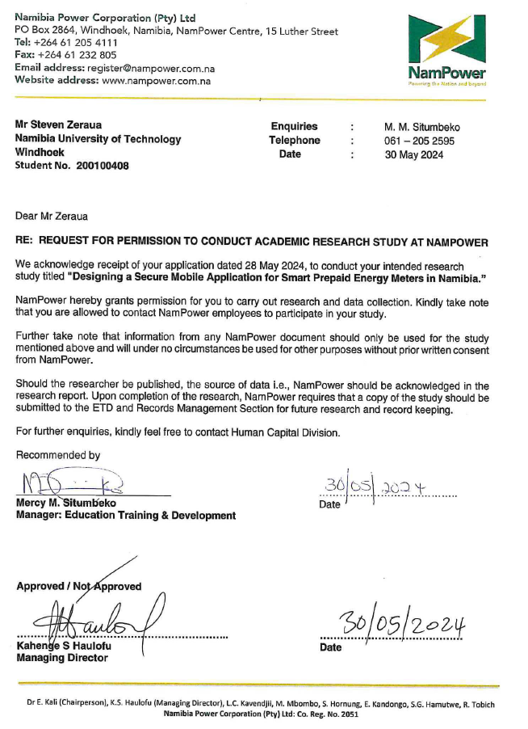

- Python Snippet
import paho.mqtt.client as mqtt
import pyodbc
import json
from datetime import datetime

# --- Configuration ---
DB_CONFIG = {
'server': 'YOUR_SERVER_ADDRESS',
'database': 'YOUR_DB_NAME',
'user': 'YOUR_USERNAME',
'password': 'YOUR_PASSWORD'
}

MQTT_BROKER = "localhost" # or your broker IP
MQTT_TOPIC = "device/+/realtime" # + is a wildcard for the Serial Number

# --- Database Connection ---
conn_str = (
f"DRIVER={{ODBC Driver 17 for SQL Server}};"
f"SERVER={DB_CONFIG['server']};"
f"DATABASE={DB_CONFIG['database']};"
f"UID={DB_CONFIG['user']};"
f"PWD={DB_CONFIG['password']}"
)

def on_message(client, userdata, msg):
try:
# Parse JSON and extract the 'Data' array
payload = json.loads(msg.payload.decode())
sn = payload.get("SN")
d = payload.get("Data") # [V, A, W, kWh_f, kWh_r, Hz, PF]

if d and len(d) >= 7:
conn = pyodbc.connect(conn_str)
cursor = conn.cursor()

sql = """INSERT INTO PowerReadings (Timestamp, SN, Voltage, Current, Power, Import, Export, Freq, PF)
VALUES (?, ?, ?, ?, ?, ?, ?, ?, ?)"""

cursor.execute(sql, (datetime.now(), sn, d[0], d[1], d[2], d[3], d[4], d[5], d[6]))
conn.commit()
cursor.close()
conn.close()
print(f"Logged data for SN: {sn}")

except Exception as e:
print(f"Error: {e}")

# --- Start Client ---
client = mqtt.Client()
client.on_message = on_message
client.connect(MQTT_BROKER, 1883, 60)
client.subscribe(MQTT_TOPIC)
client.loop_forever()

